**CS 682 Home Work III**

**KRISHNA SINDHURI VEMURI**

**G01024066**

I have used the 4001 and 4050 images for illustrating the results of the program.

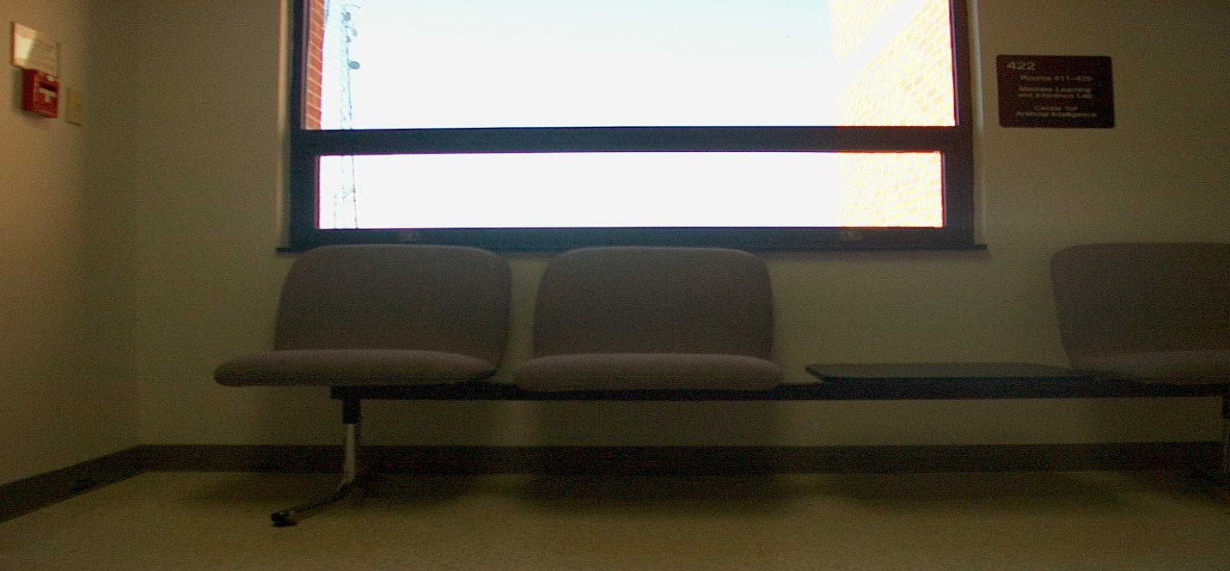

ST2MainHall4001.jpg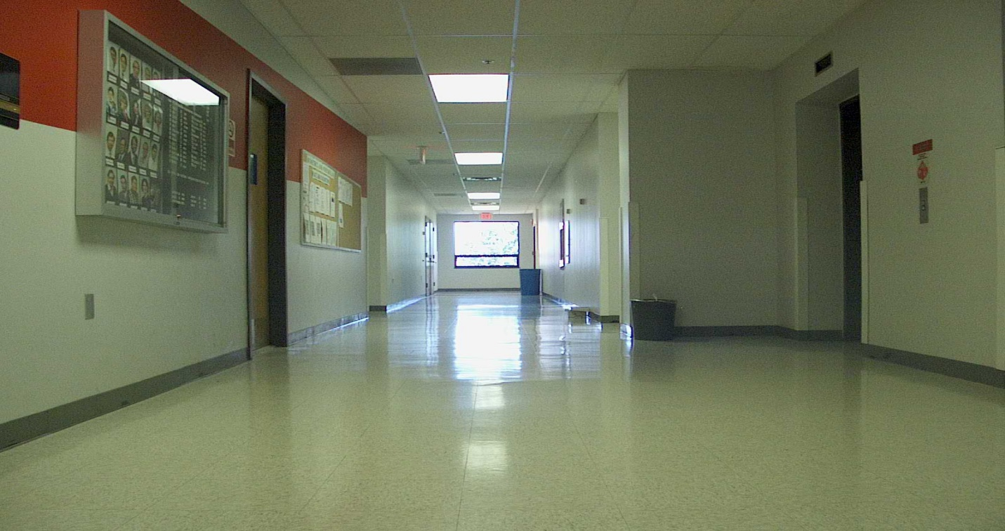

ST2MainHall4050.jpg

To compute the gray level edges for the images, first we need to convert the original image into gray.

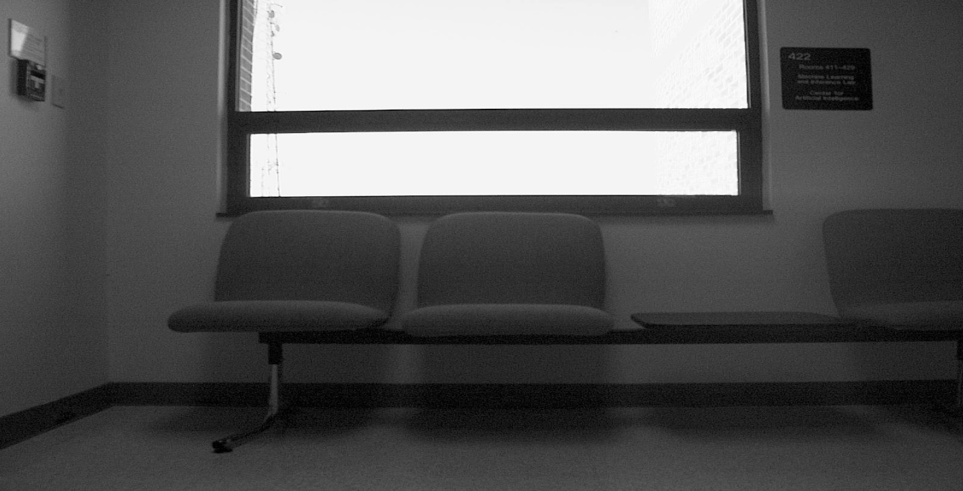

Gray4001.jpg

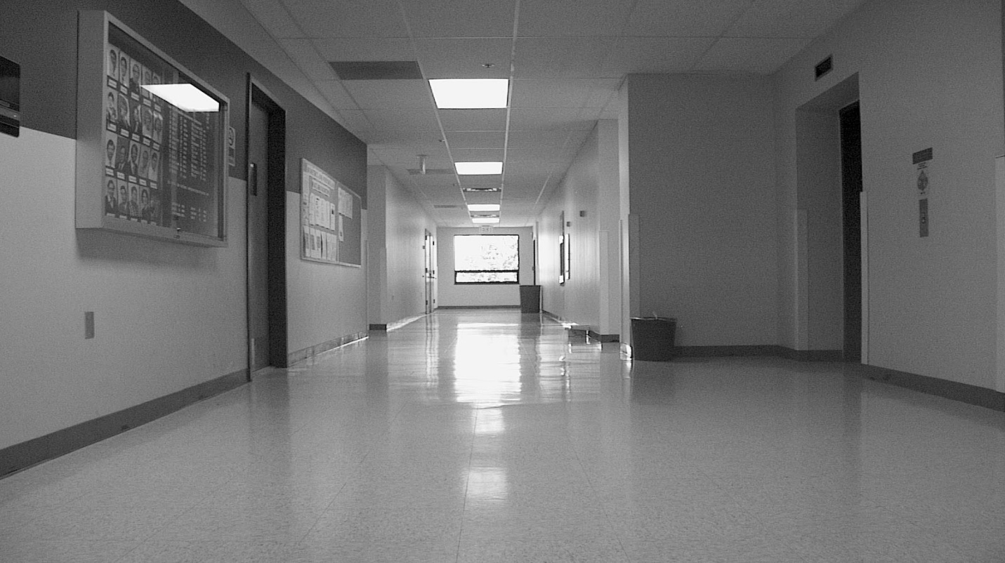

Gray4050.jpg

Then I have blurred all the images using the Gaussian Filter with kernel width and height as 7 pixels and sigma as 2.

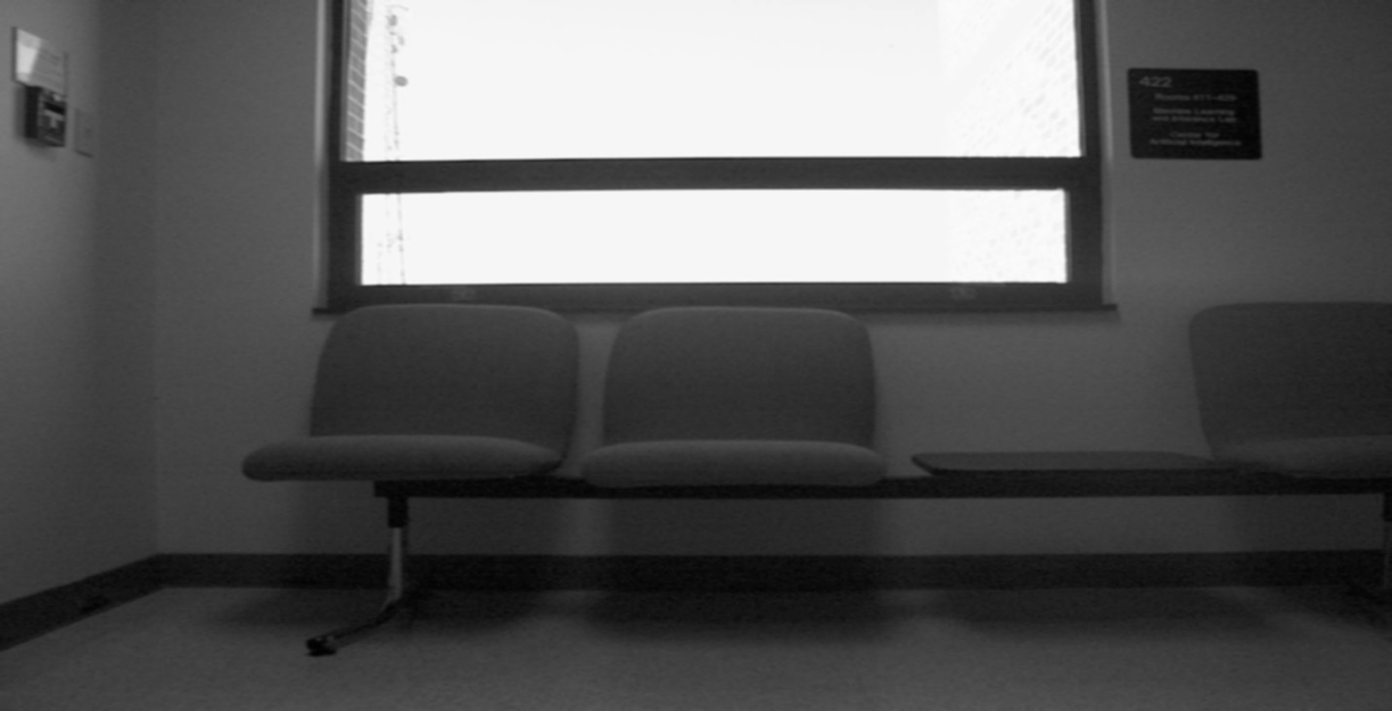

Blur4001.jpg

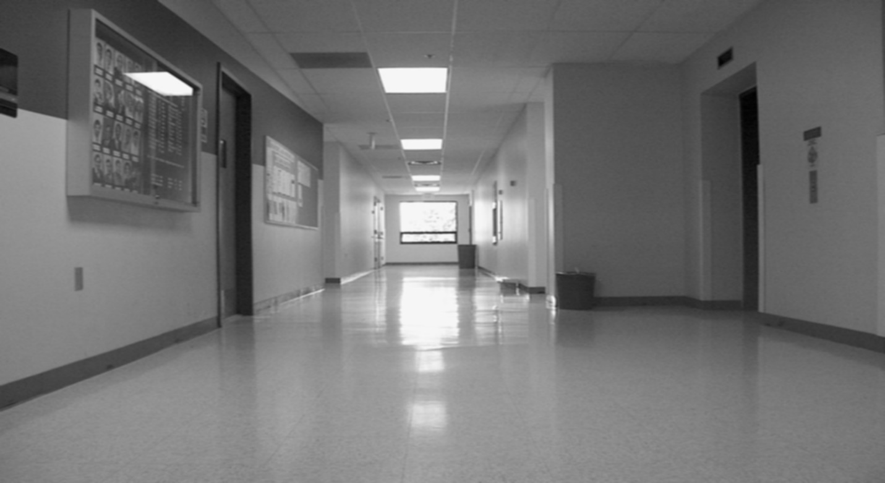

Blur4050.jpg

After blurring the image most of the noise is removed and using the canny edge detection algorithm with low threshold as 100 and high threshold as 200, we detect the edges in all the images.

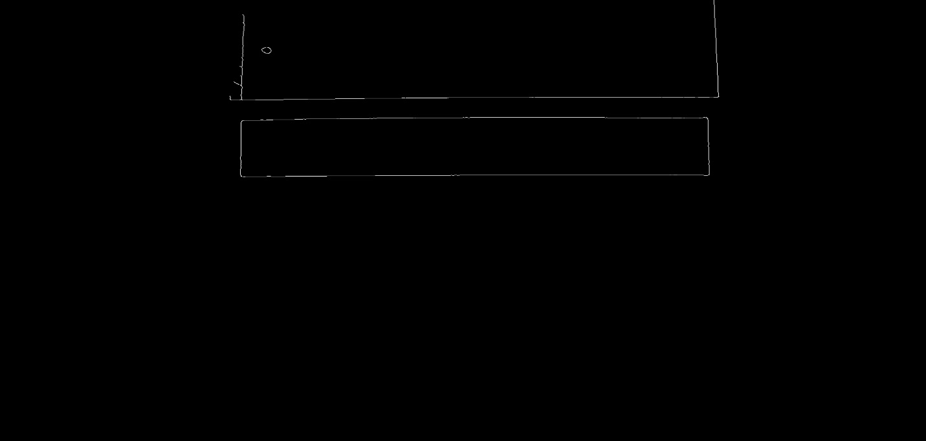

Canny4001.jpg

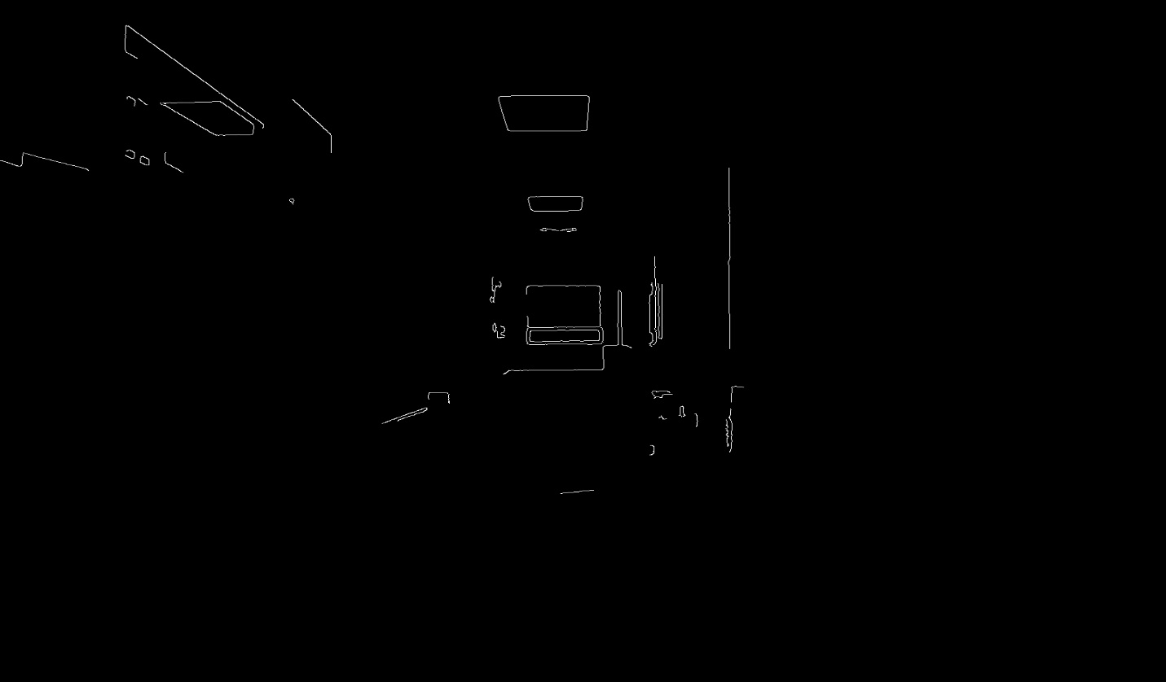

Canny4050.jpg

Also, we find the X and Y gradients of the blurred images.

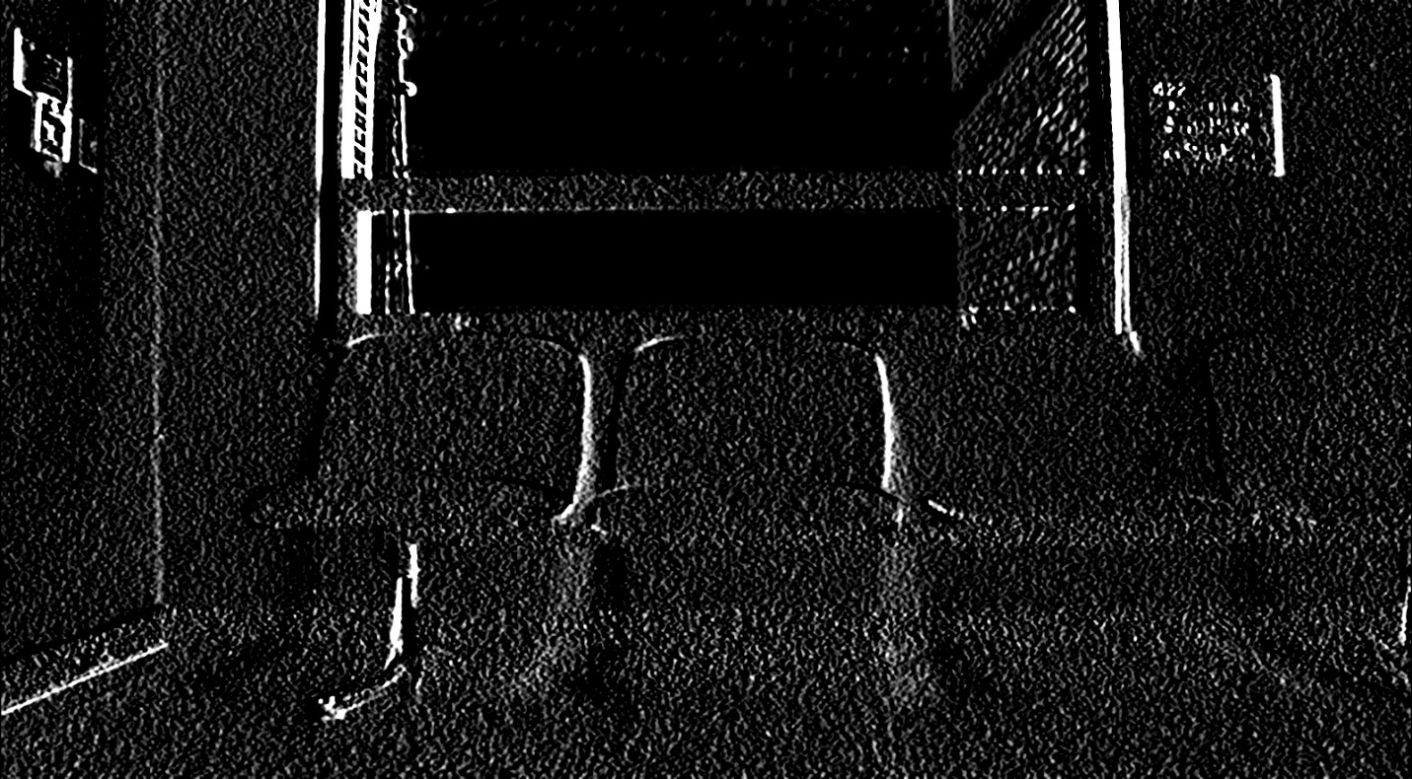

Gx4001.jpg

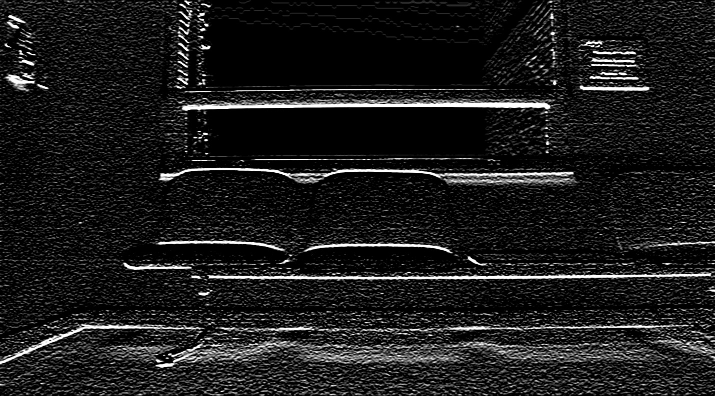

Gy4001.jpg

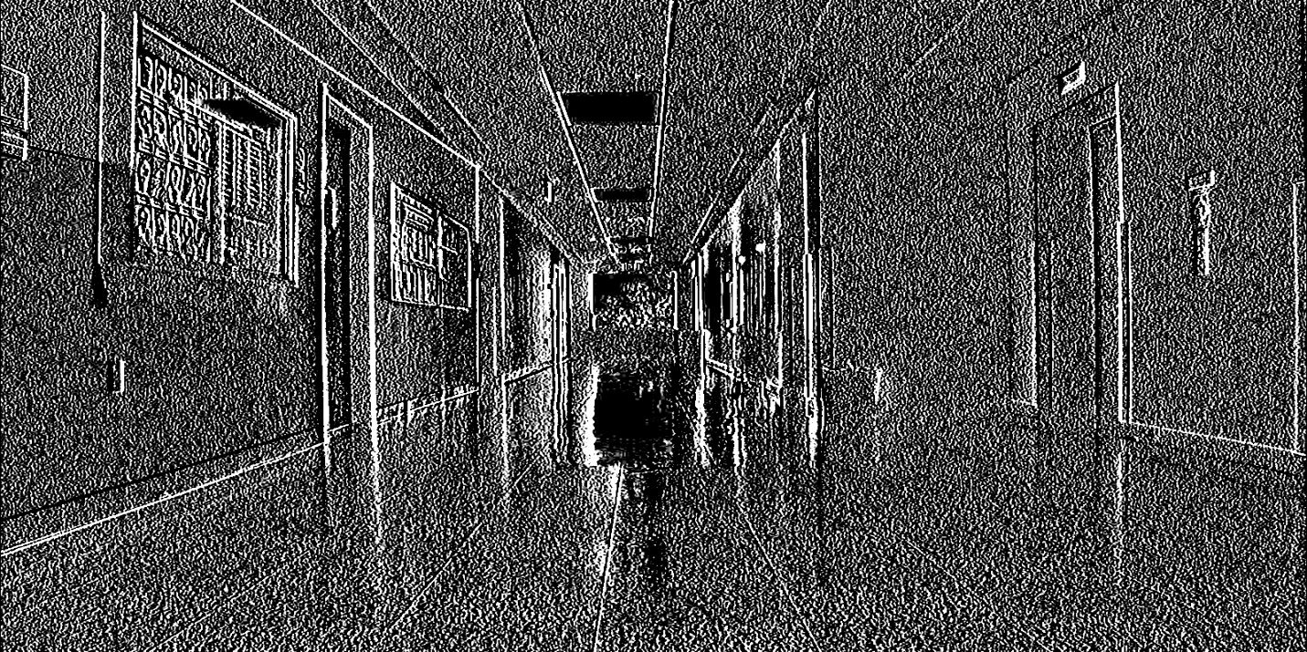

Gx4050.jpg

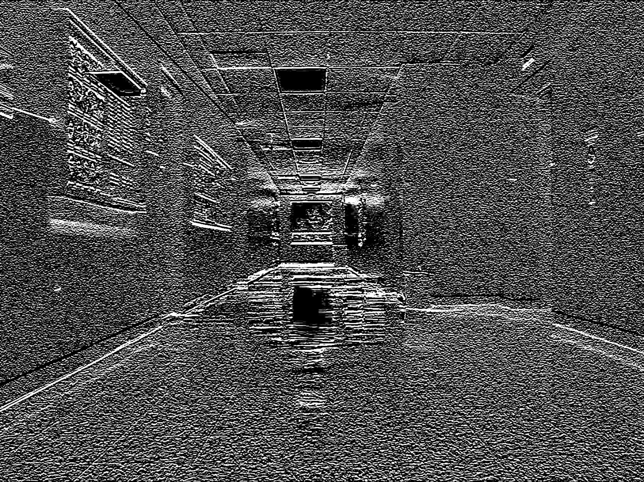Gy4050.jpg

Using the cartToPolar built in function from OpenCV, we calculate the magnitude and phase of the gradients.

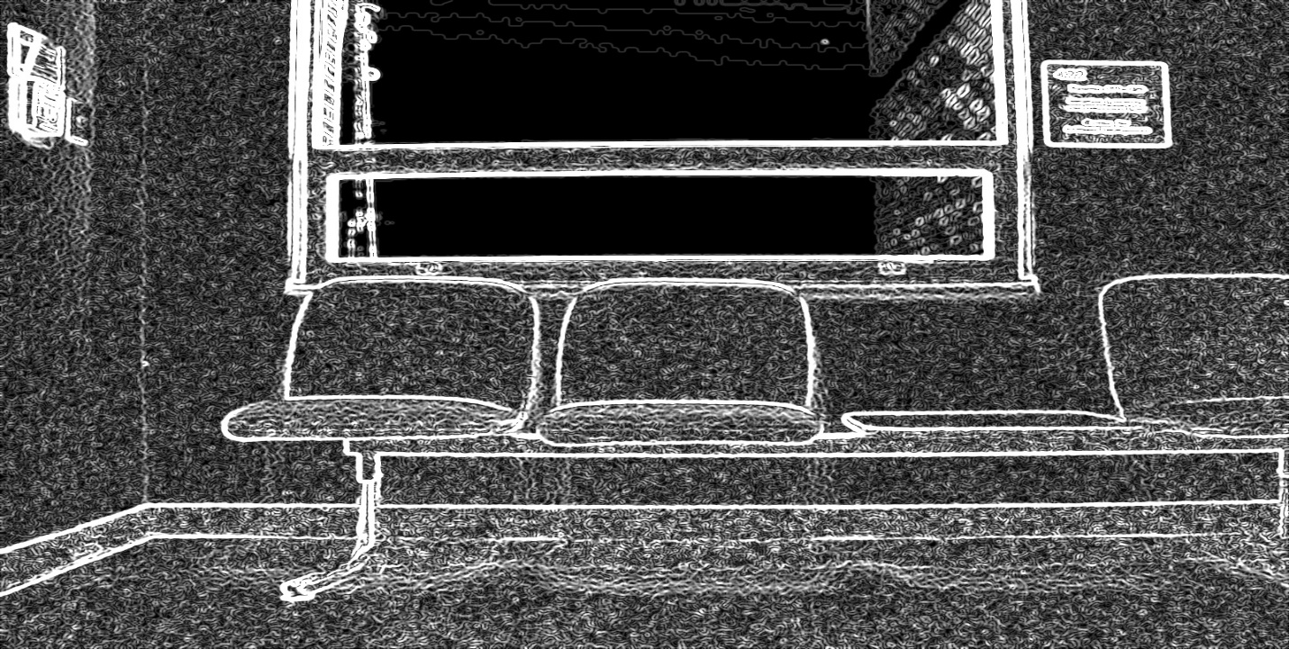

Magnitude4001.jpg

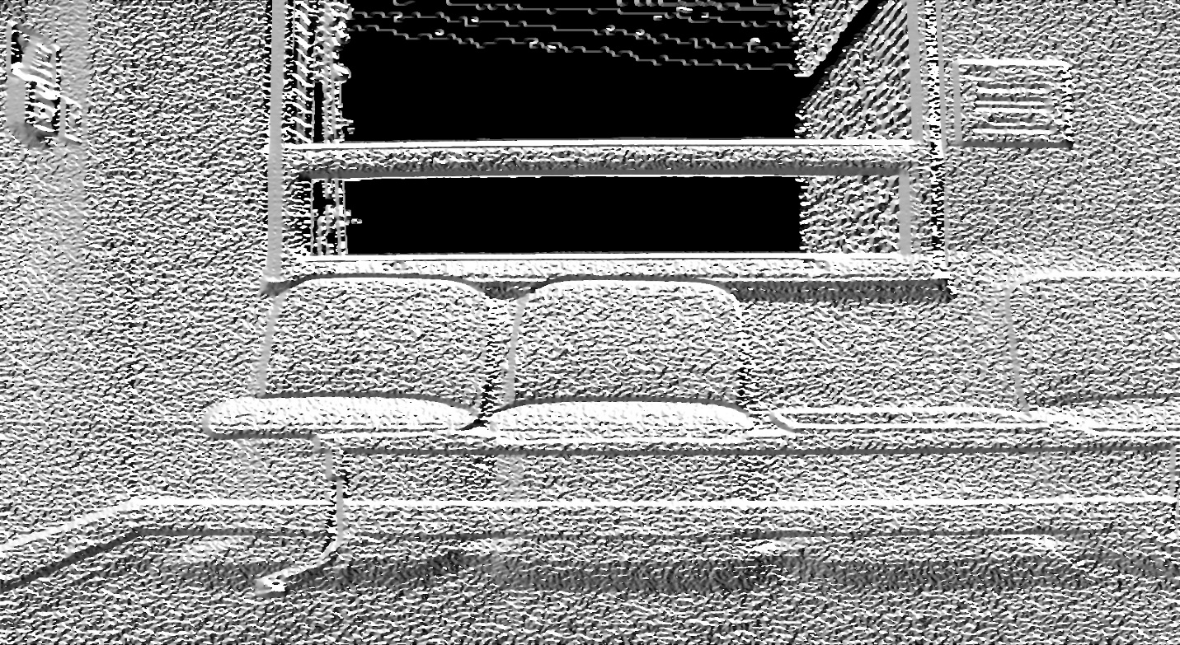

Phase4001.jpg

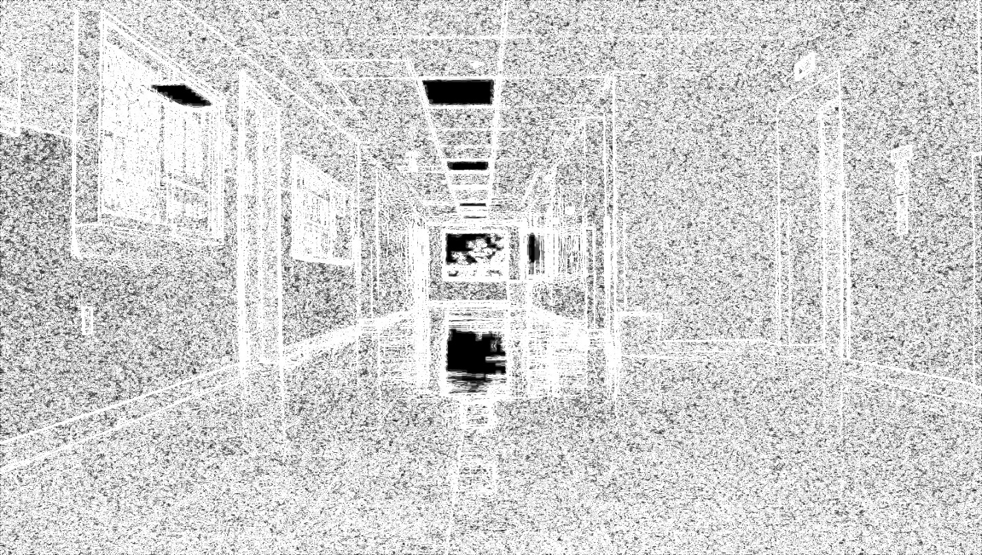

Magnitude4050.jpg

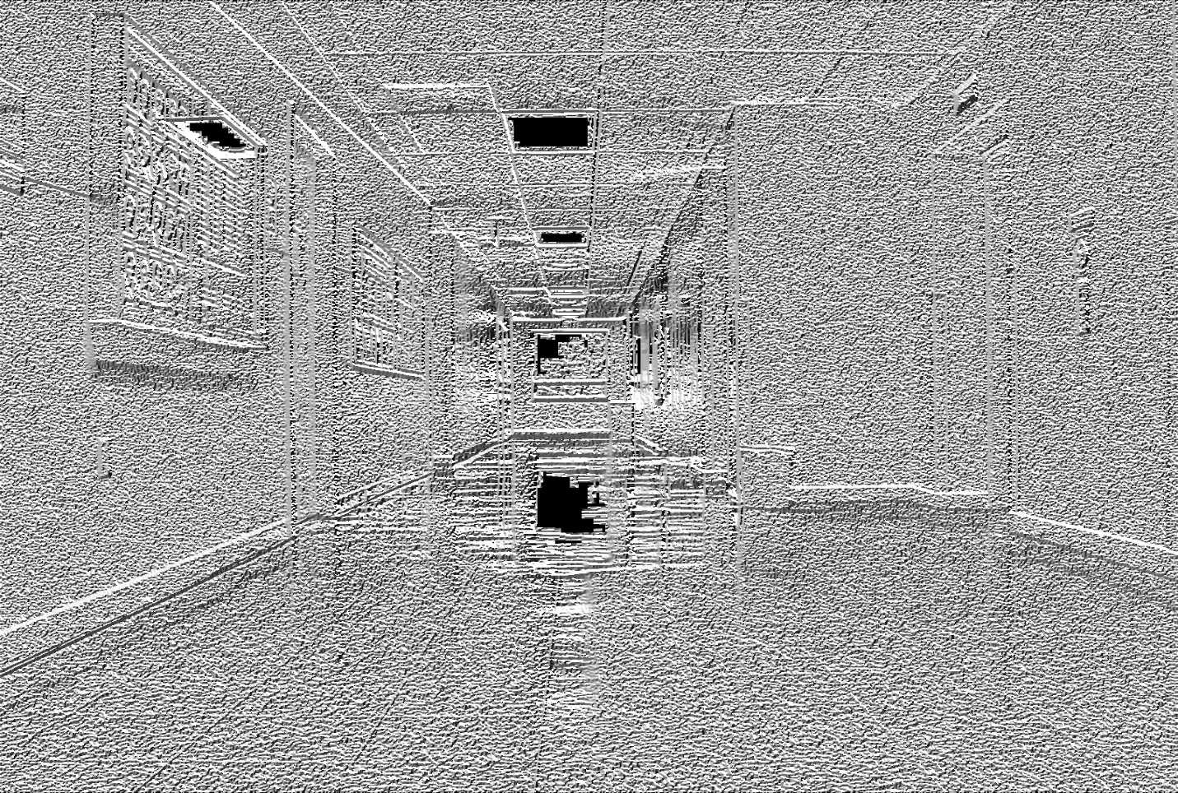

Phase4050.jpg

Also, we divide and round the phase to make it to fall in 36-bin range.

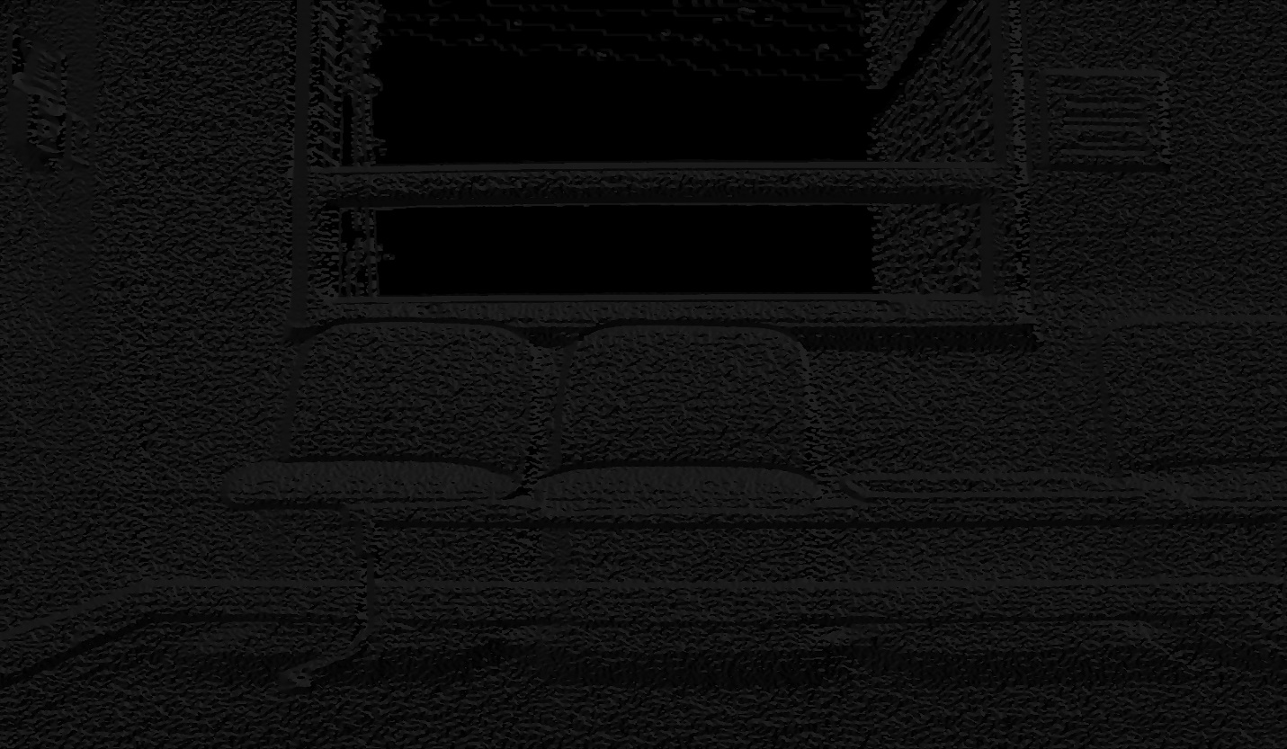

Angle4001.jpg

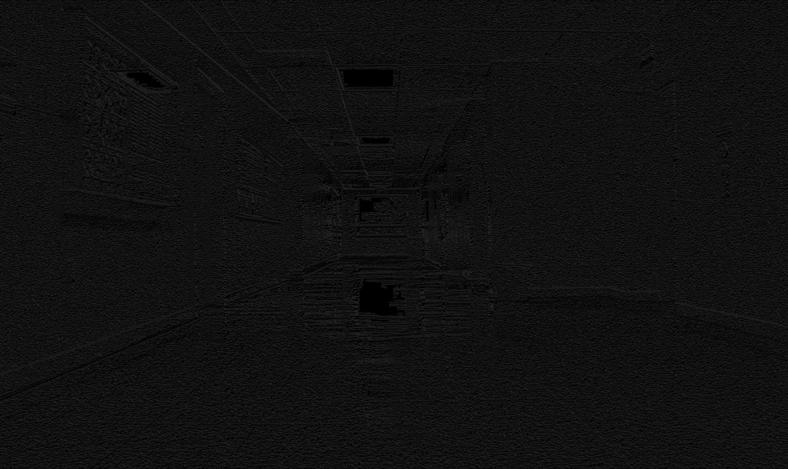

Angle4050.jpg

Later we use the canny edge detection image as a mask and plot histograms for the angles in the images. This masking helps to eliminate all the unwanted edges into consideration.

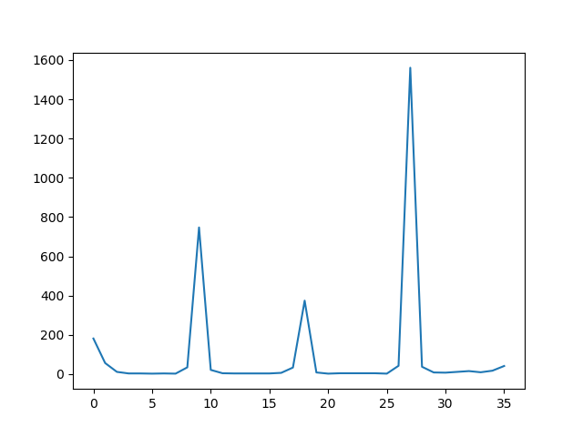

GrayHist4001.jpg

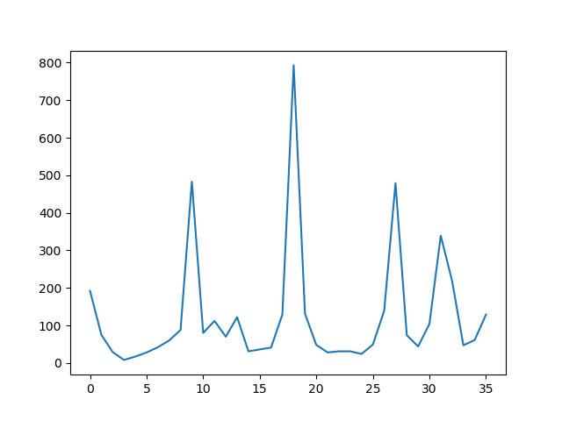

Gray4050.jpg

To compute the color level edge histograms, we first blur the original images with the same parameters given for the gray images.

We split the blur image into the RGB channels.

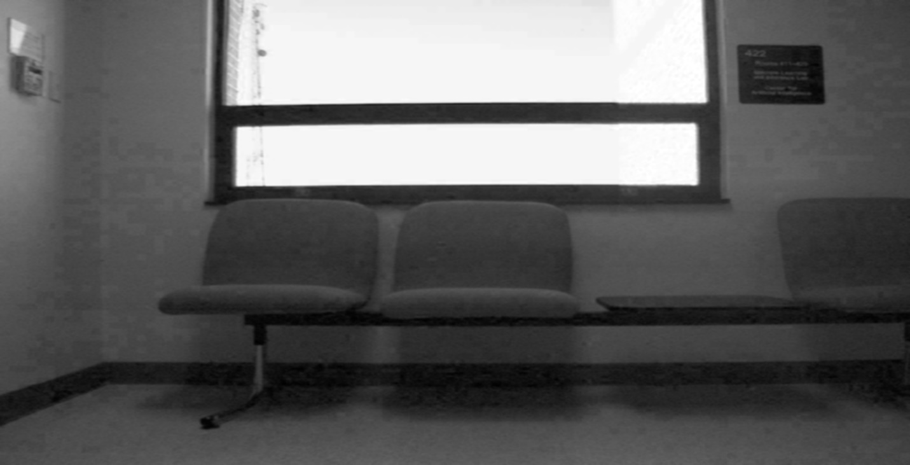

R4001.jpg

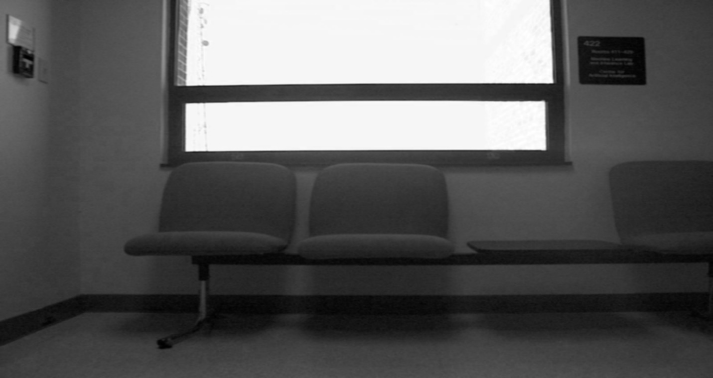

G4001.jpg

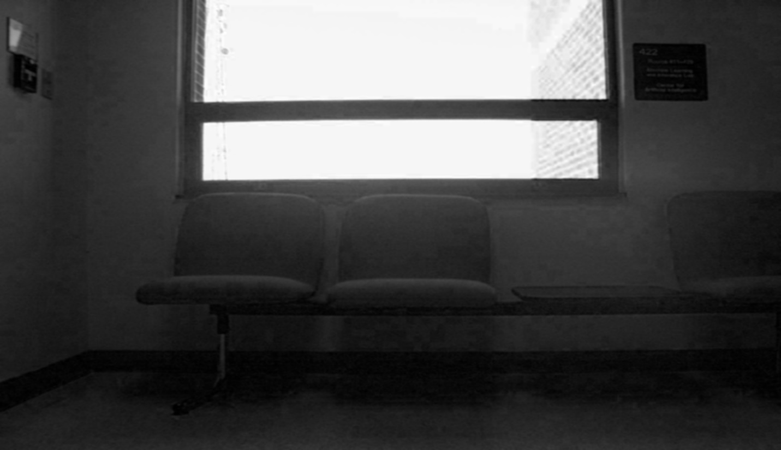

B4001.jpg

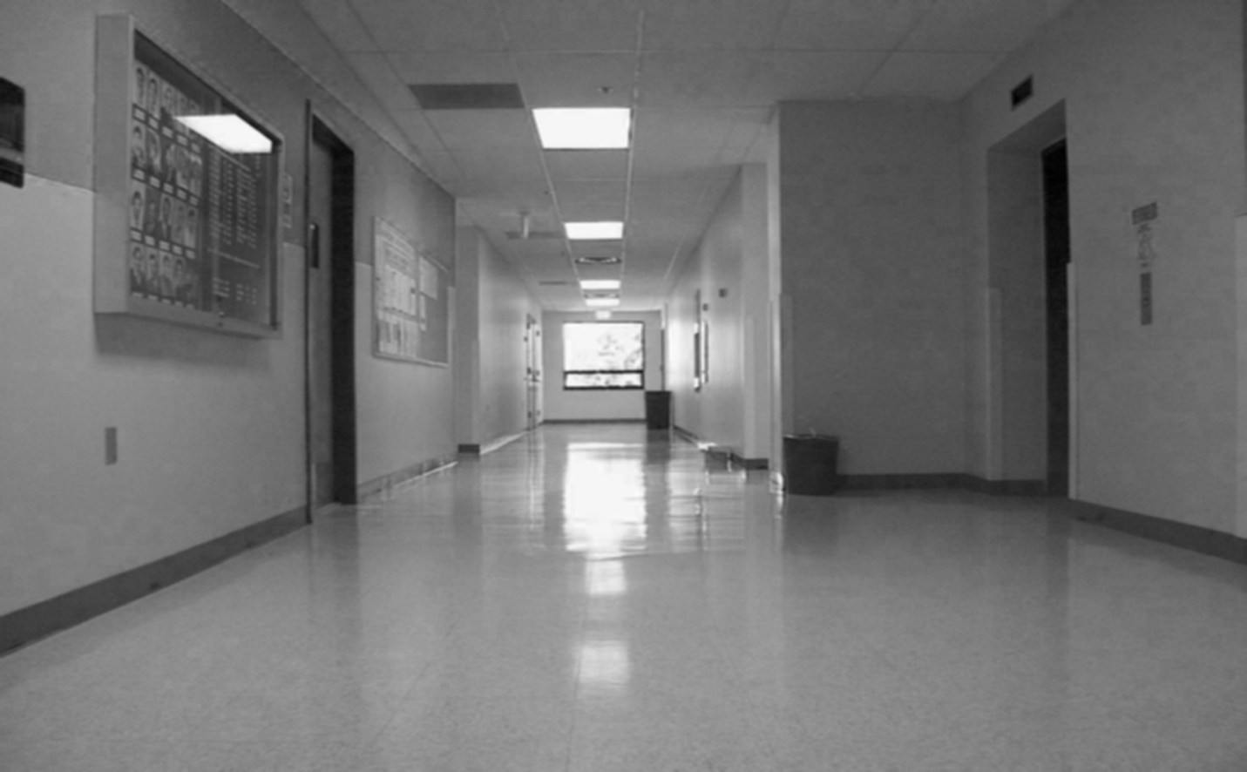

R4050.jpg

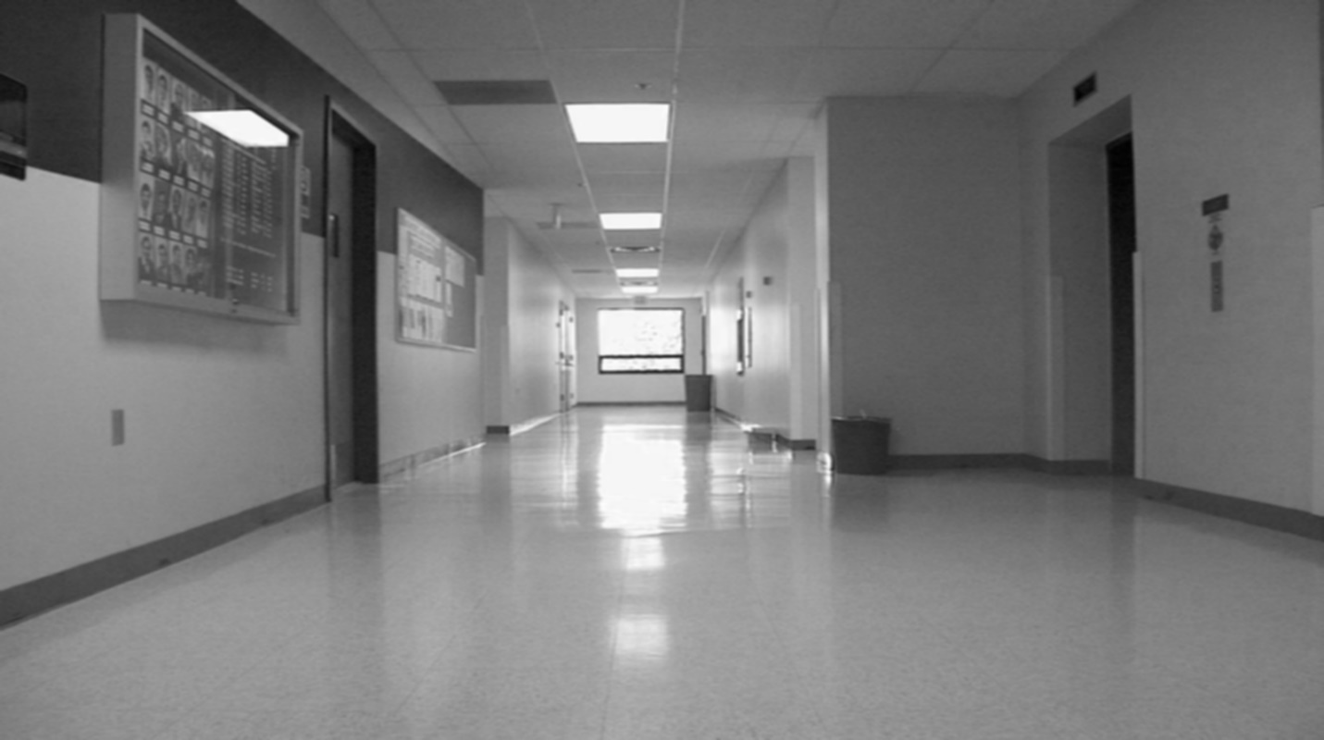

G4050.jpg

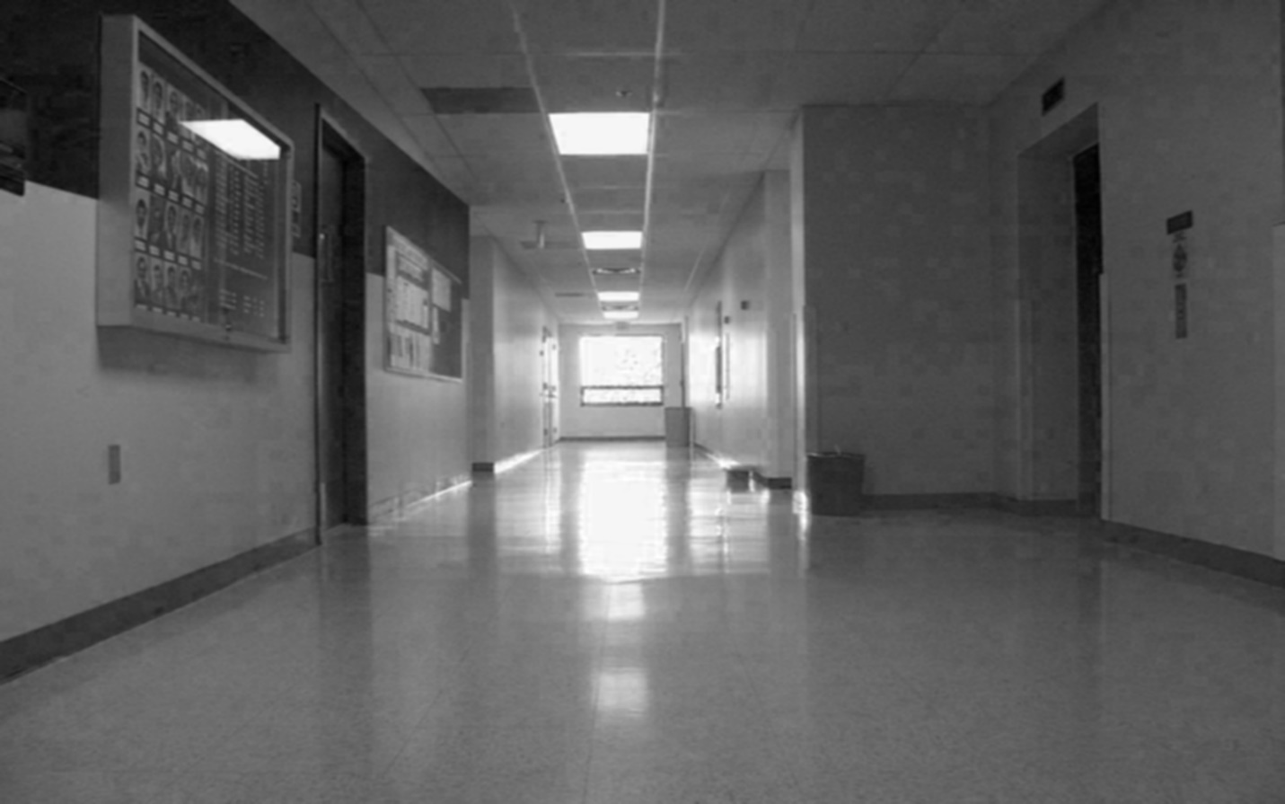

B4050.jpg

We find the canny edges for all the three channels by giving the lower threshold as 100 and higher threshold as 200.

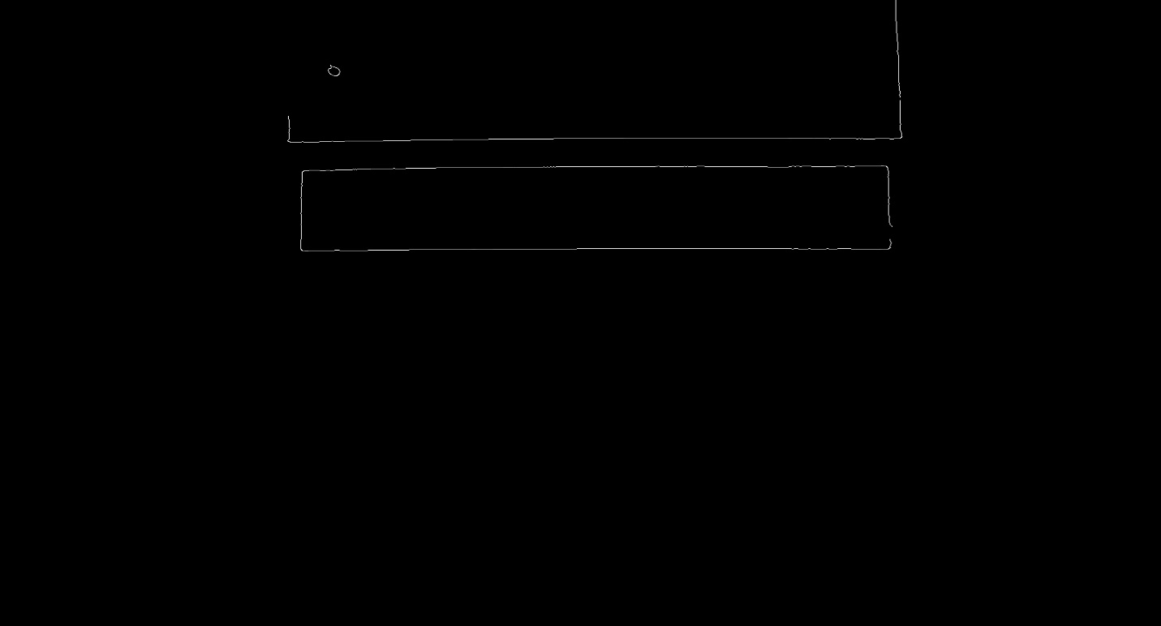

RCanny4001.jpg

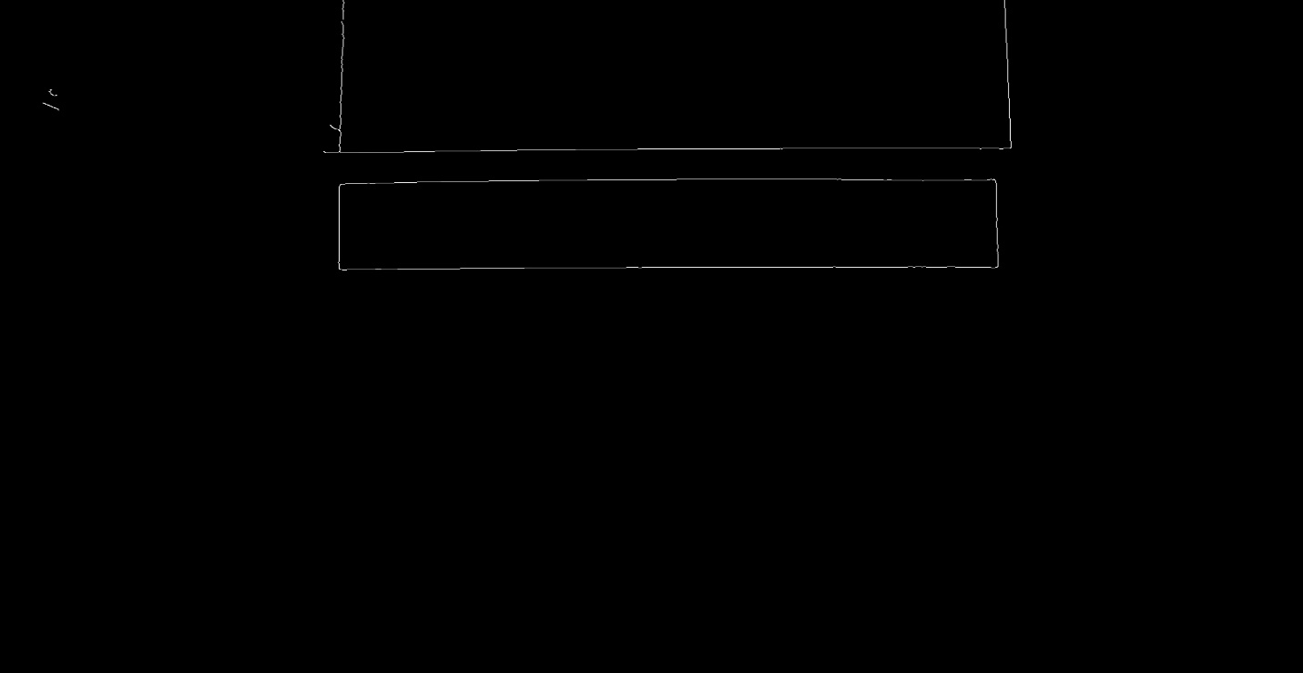

GCanny4001.jpg

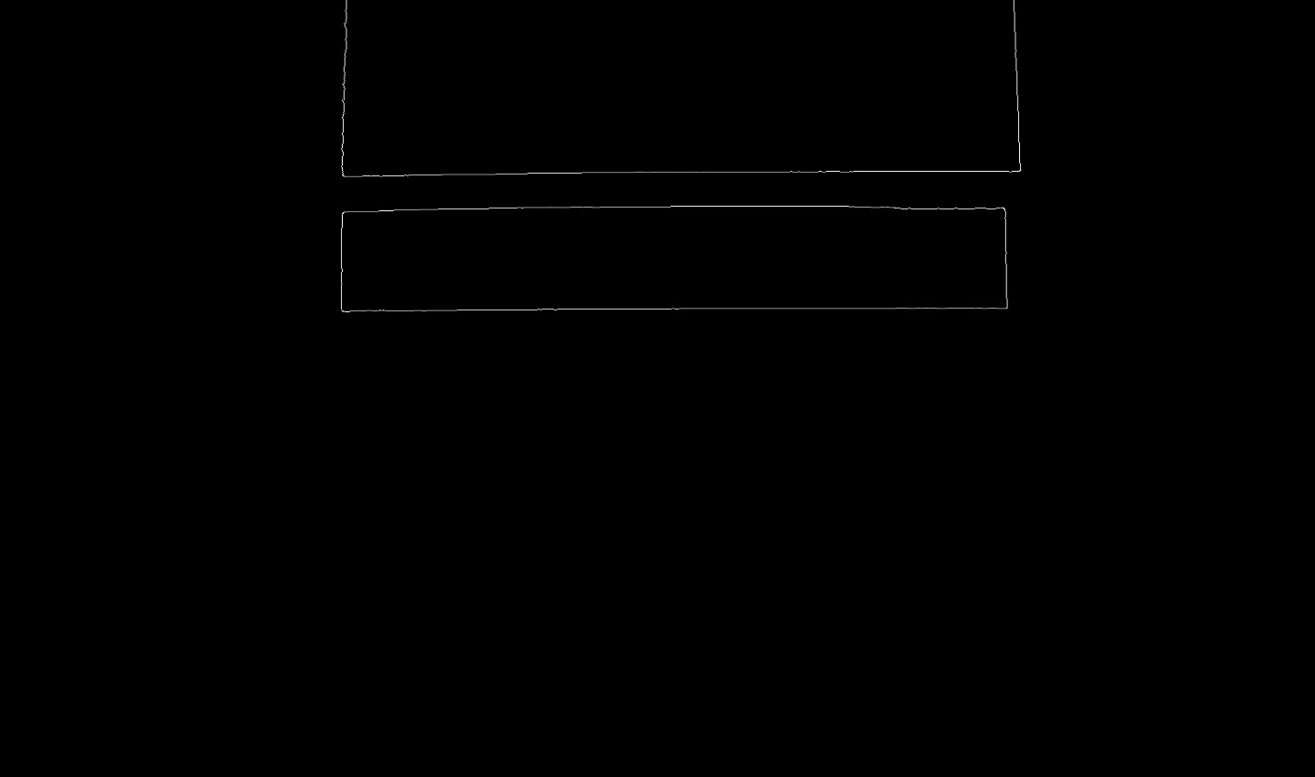

BCanny4001.jpg

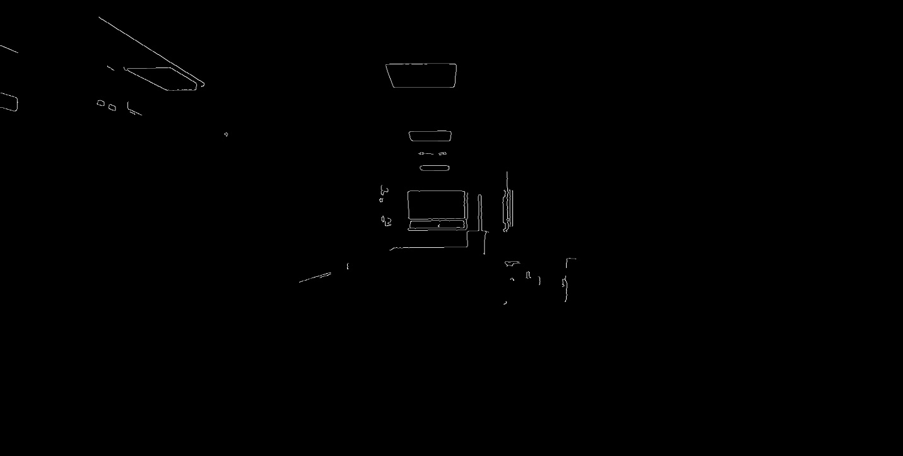

RCanny4050.jpg

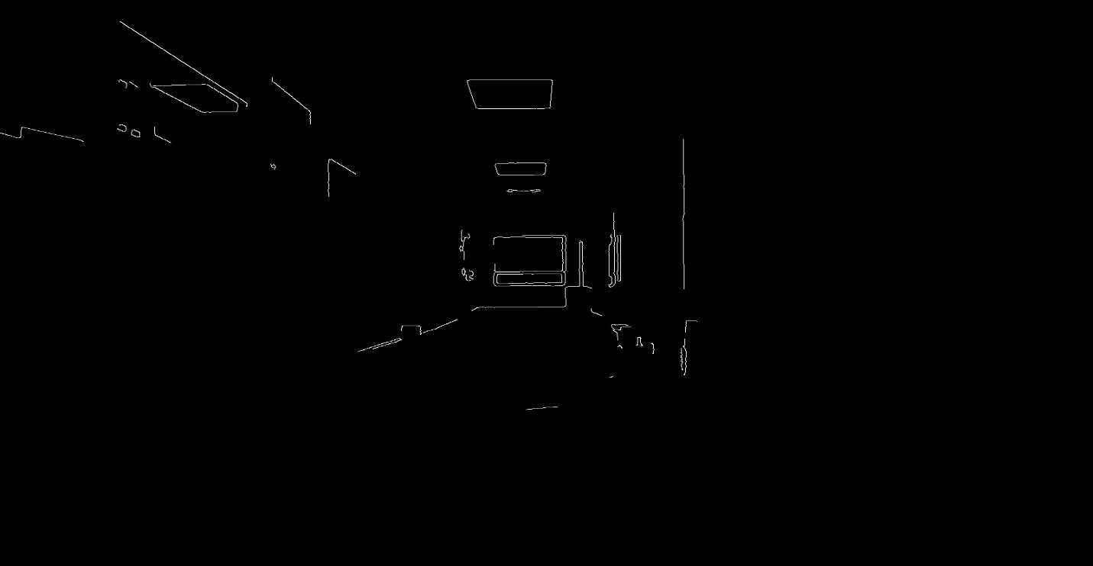

GCanny4050.jpg

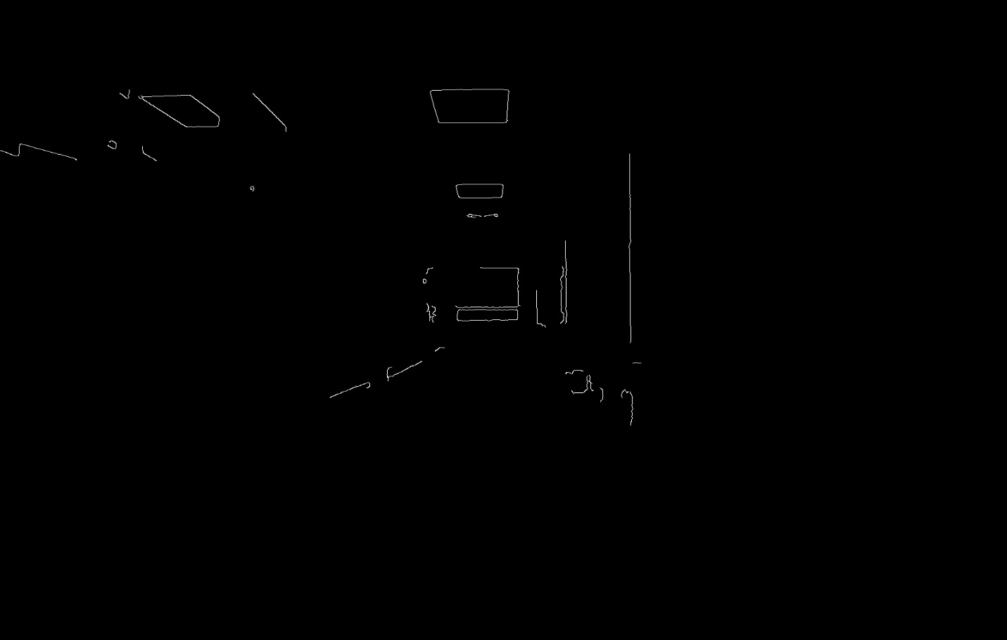

BCanny4050.jpg

Add all the RGB canny edges to get the final mask for building the histograms.

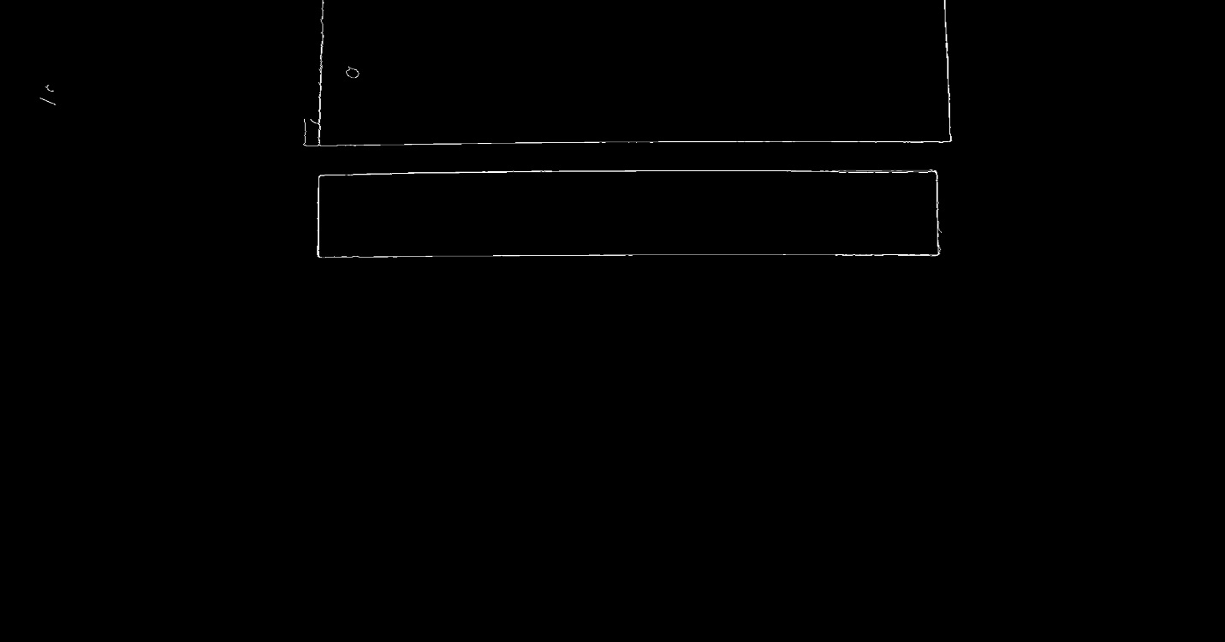

Canny4001.jpg

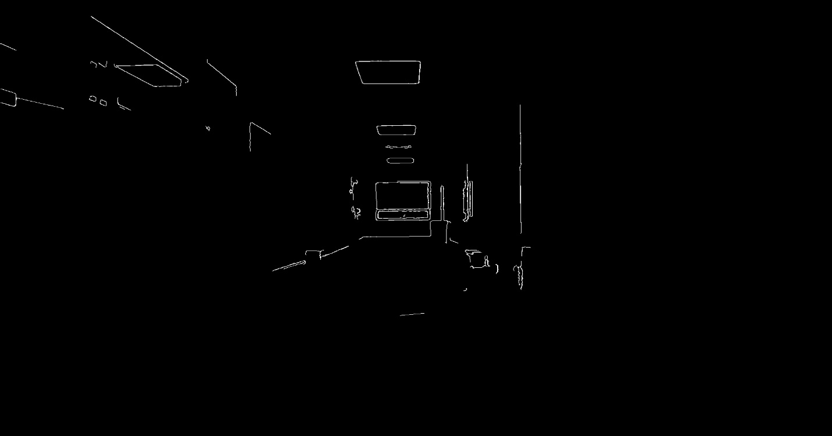

Canny4050.jpg

I then find the gradients for all the R G and B images.

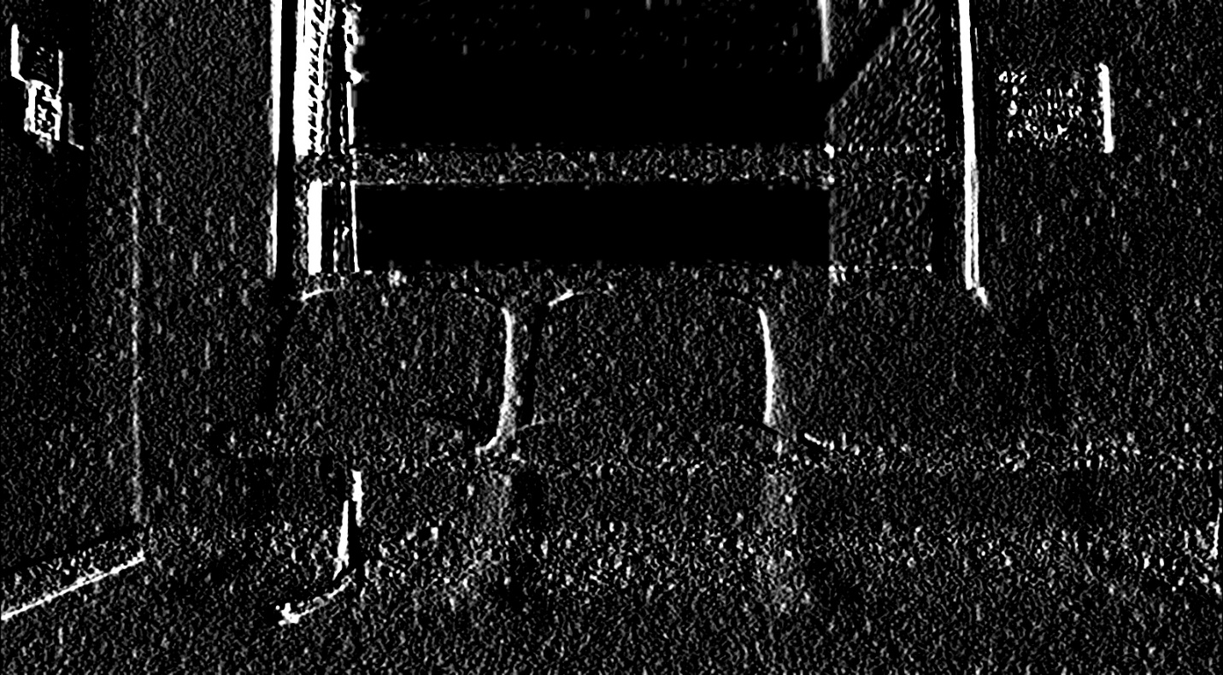

Rx4001.jpg

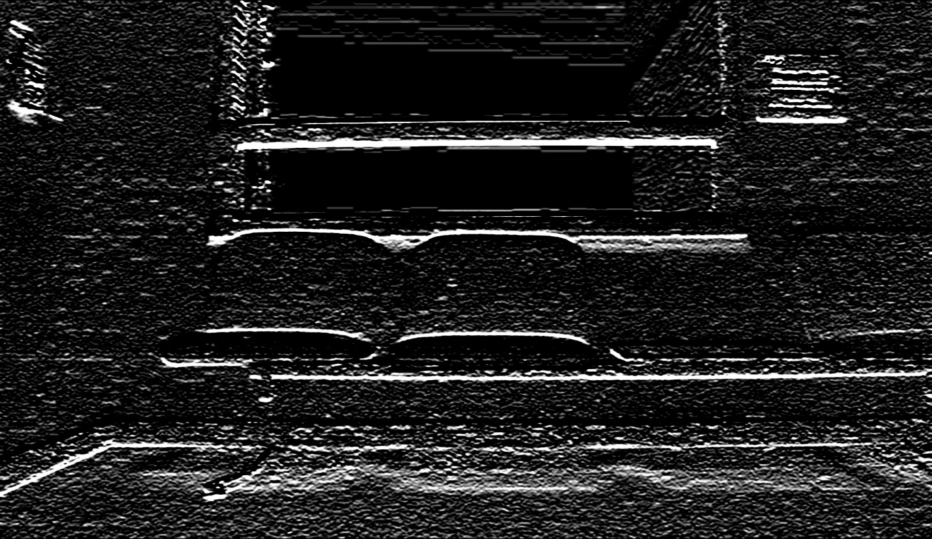

Ry4001.jpg

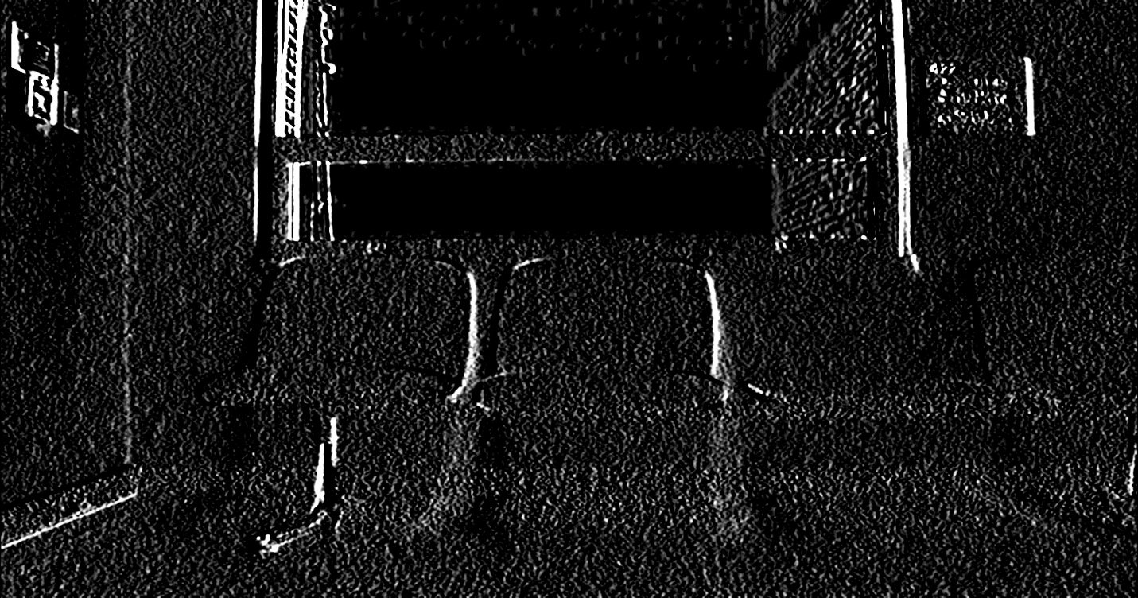

Gx4001.jpg

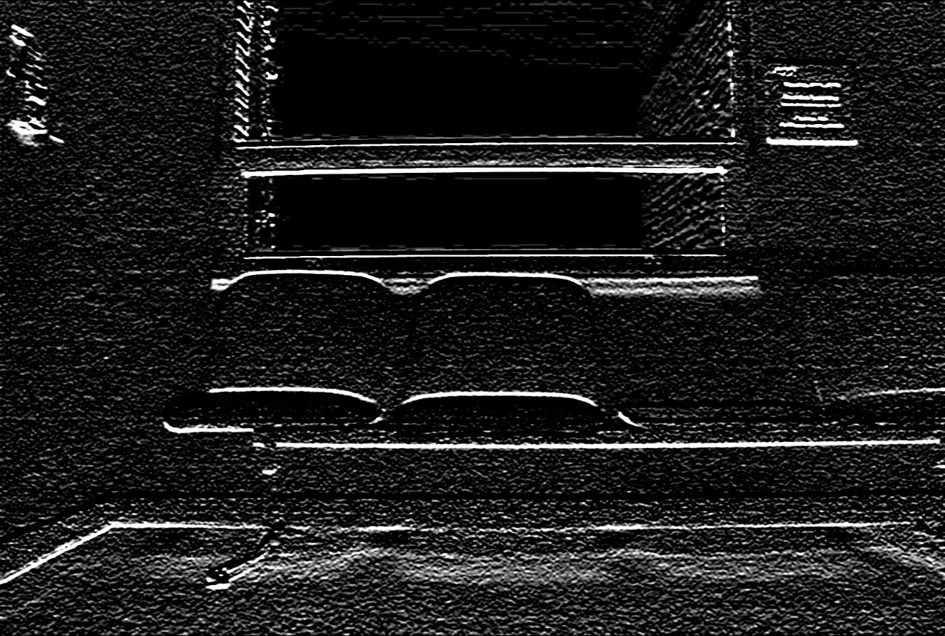

Gy4001.jpg

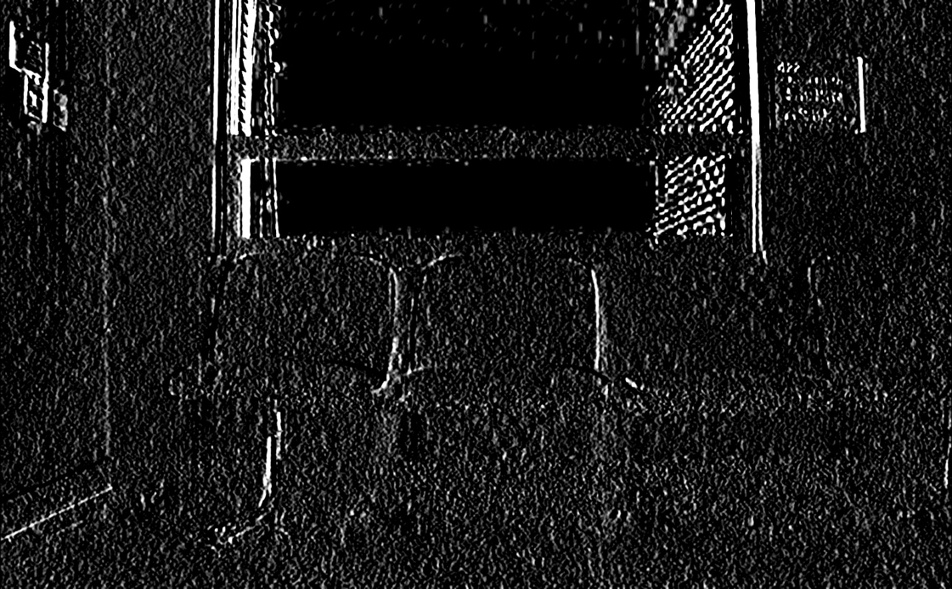

Bx4001.jpg

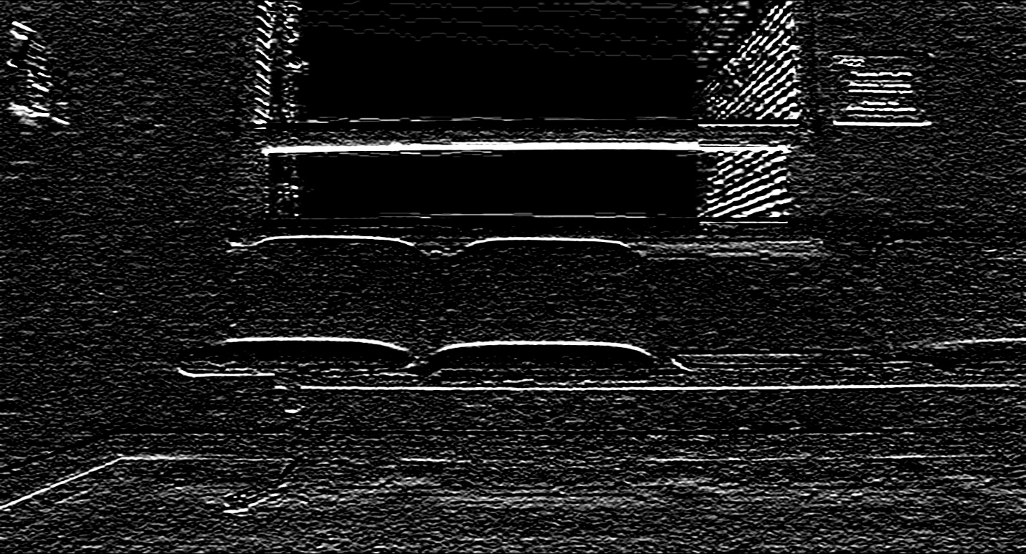

By4001.jpg

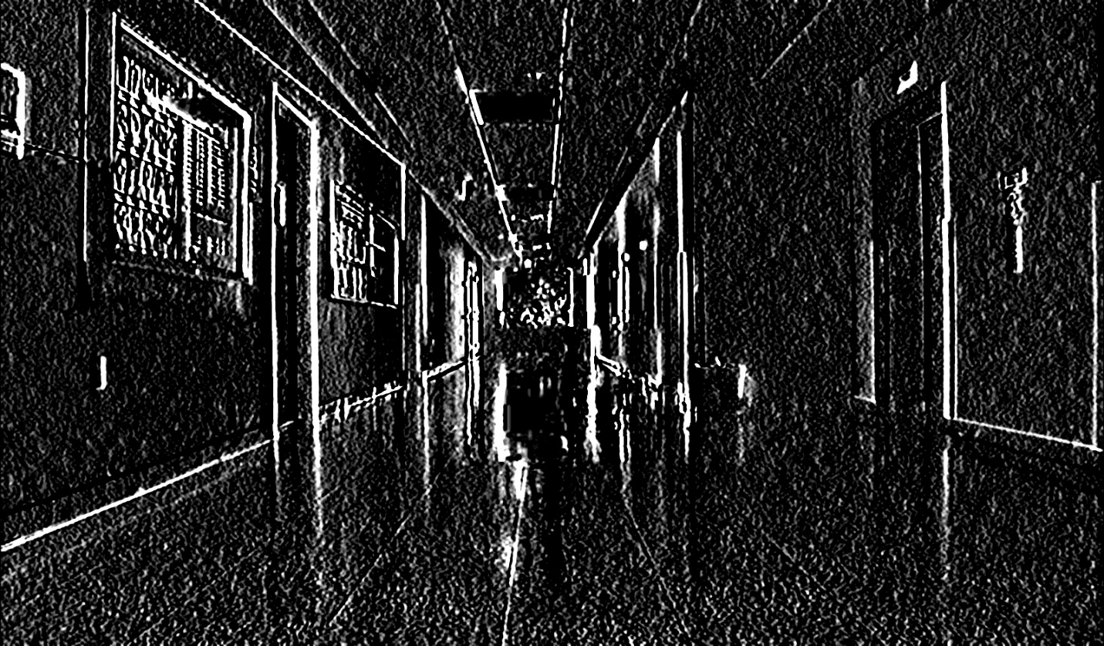

Rx4050.jpg

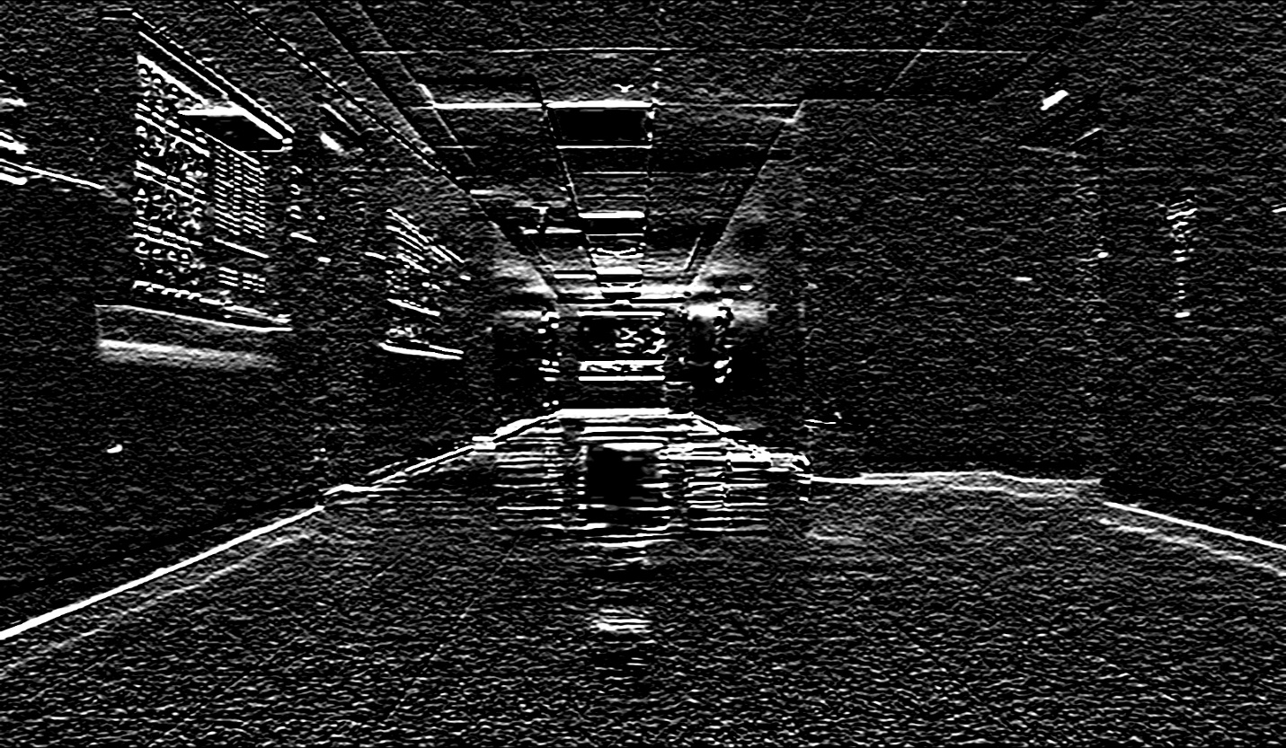

Ry4050.jpg

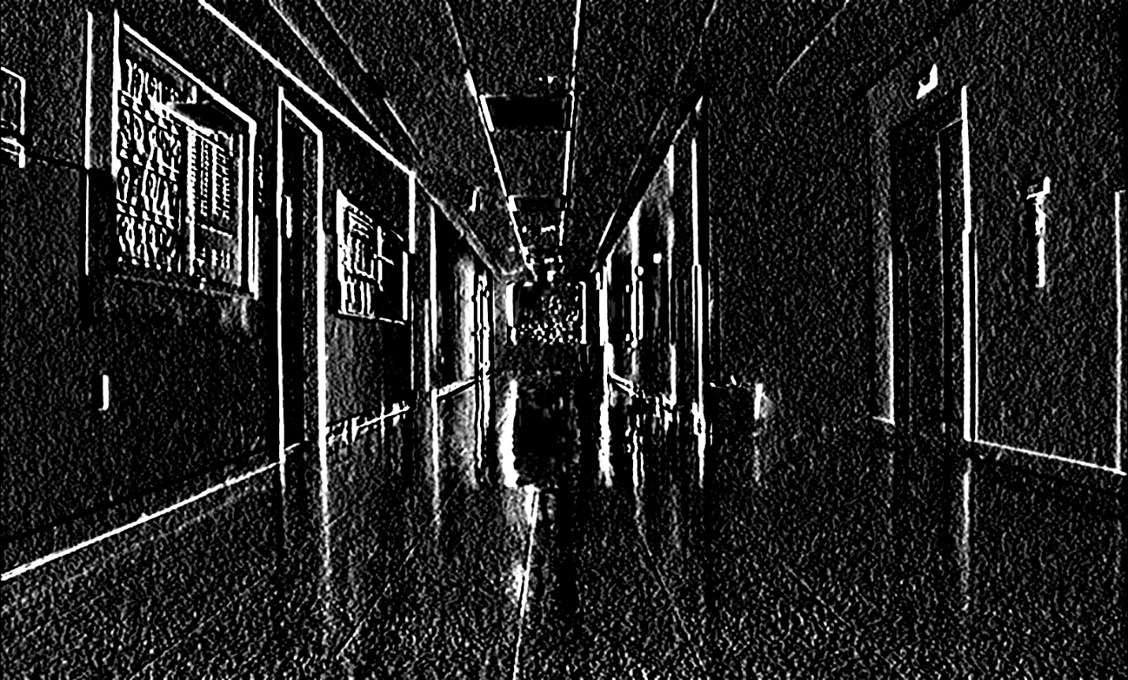

Gx4050.jpg

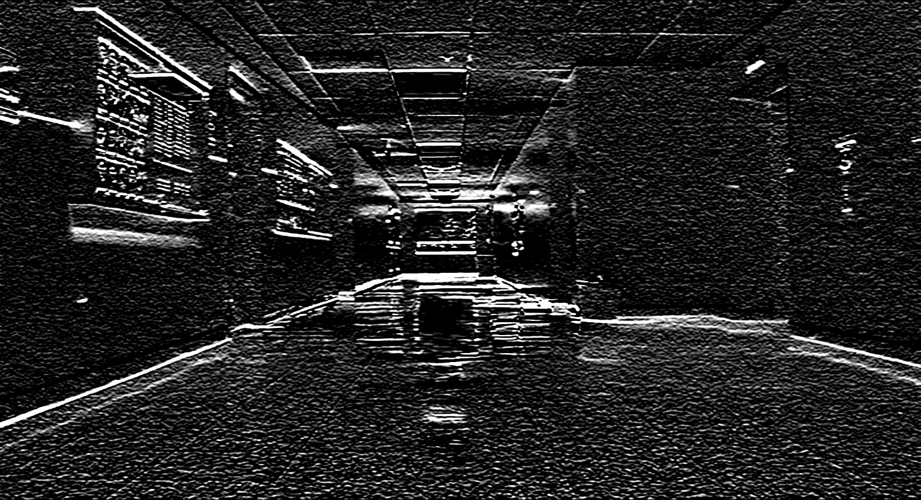

Gy4050.jpg

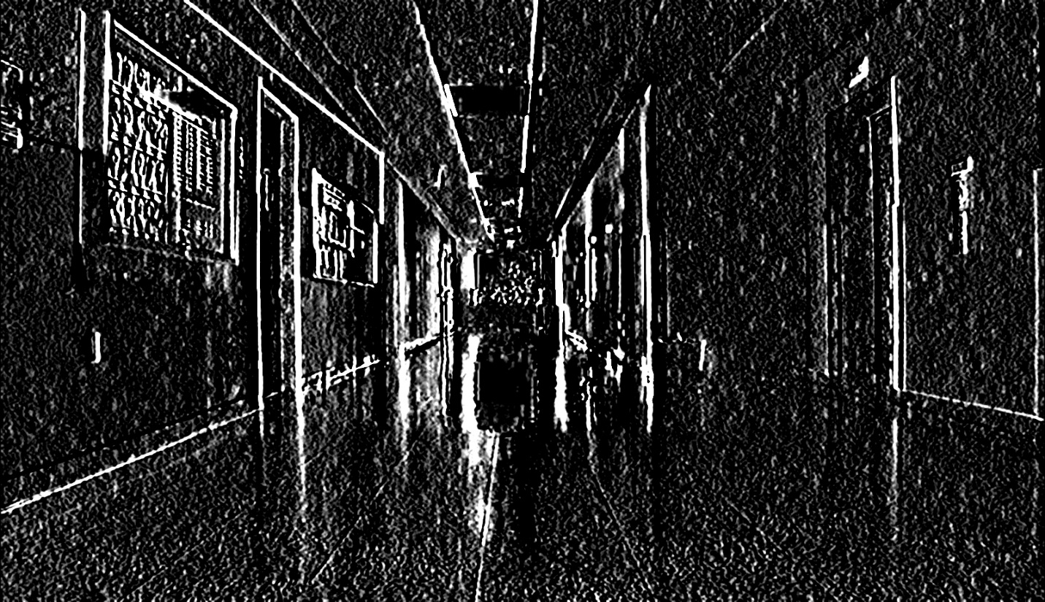

Bx4050.jpg

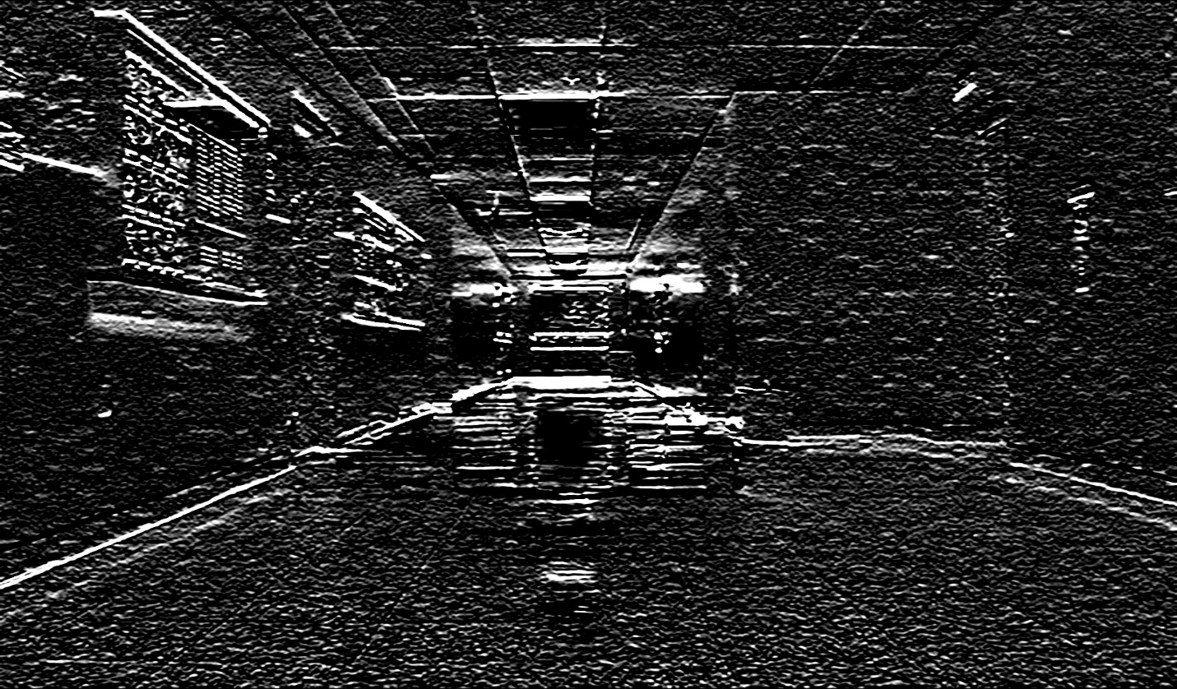

By4050.jpg

Finally create the U and V vectors, U = Rx+Gx+Bx and V = Ry+Gy+By

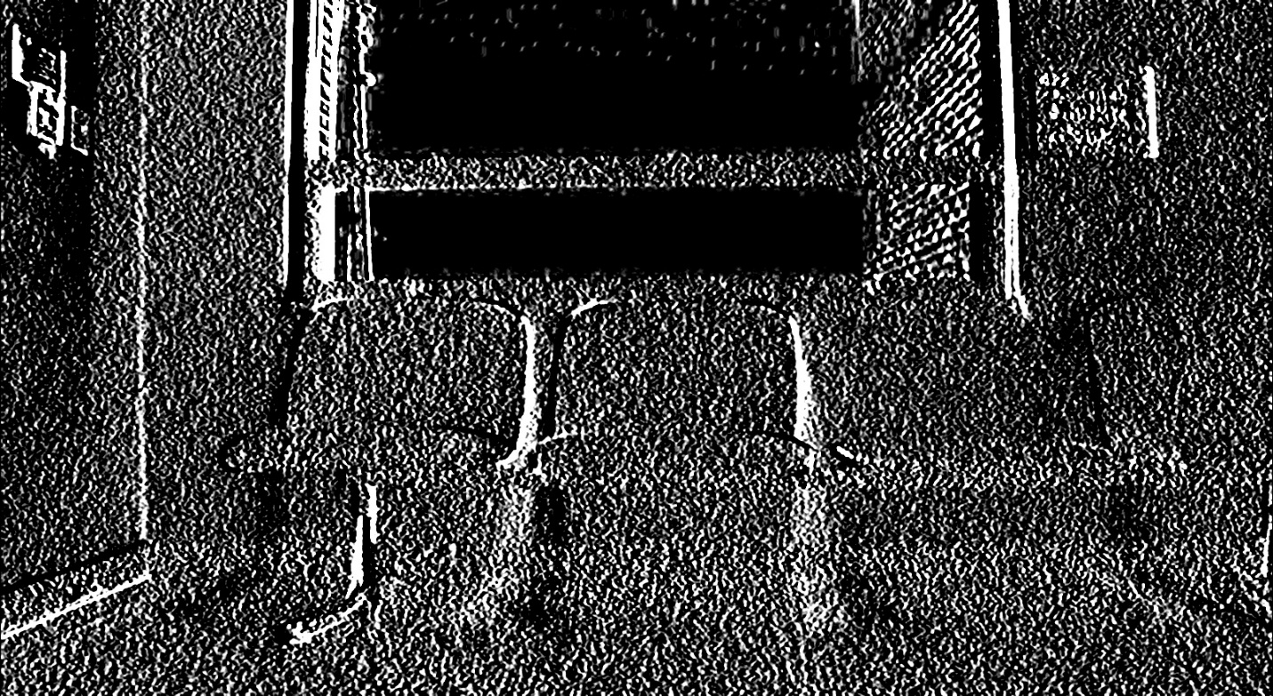

U4001.jpg

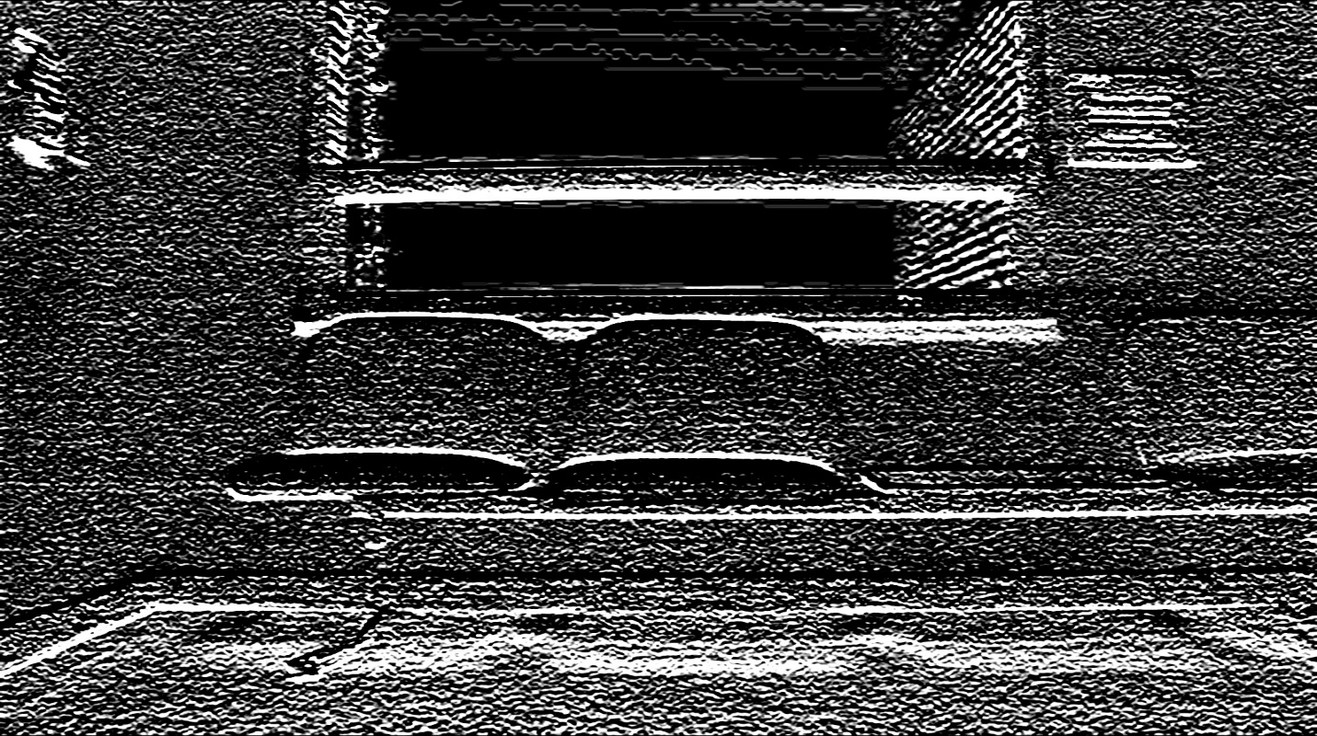

V4001.jpg

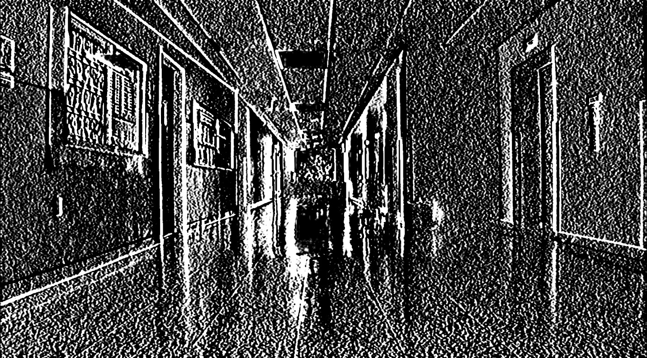

U4050.jpg

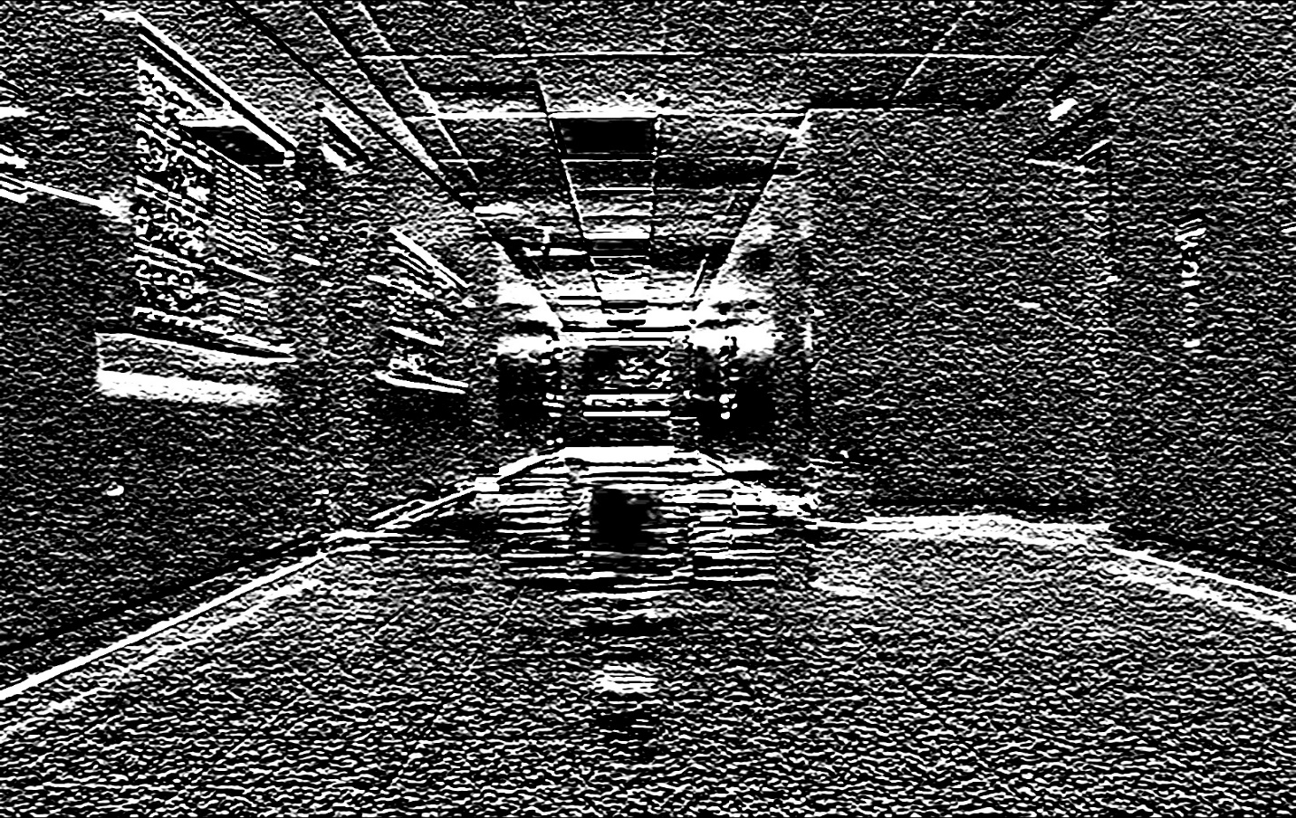

V4050.jpg

Using the cartToPolar built in function from OpenCV, we calculate the magnitude and phase of the U and V vectors.

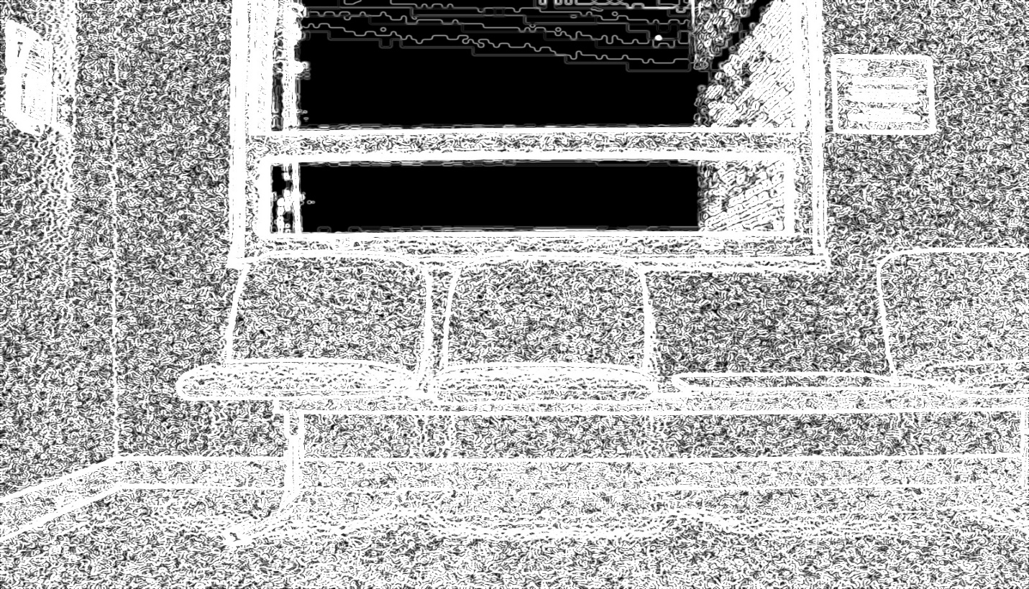

Magnitude4001.jpg

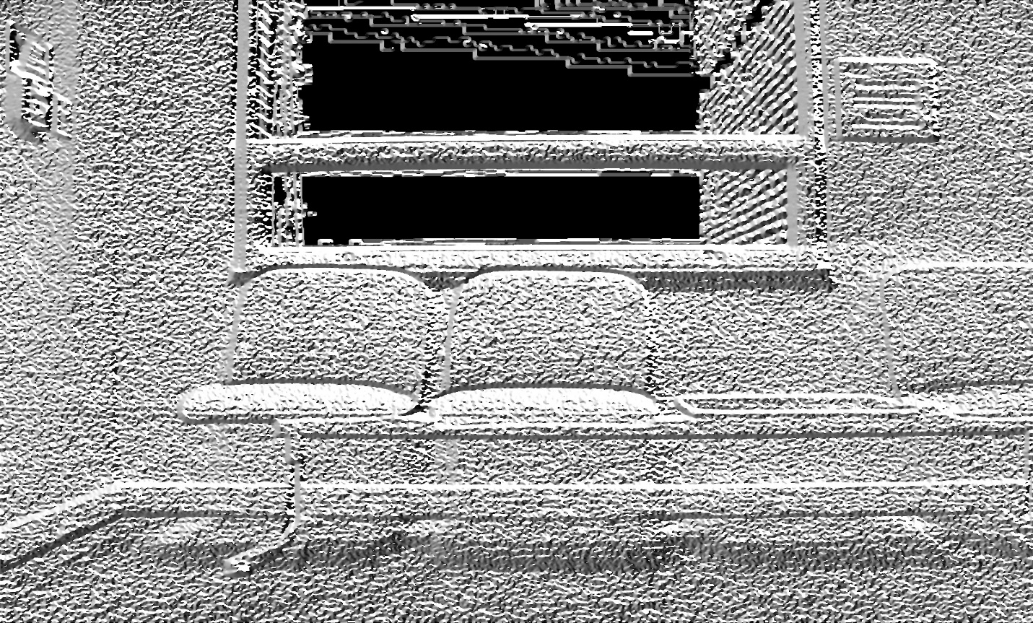

Phase4001.jpg

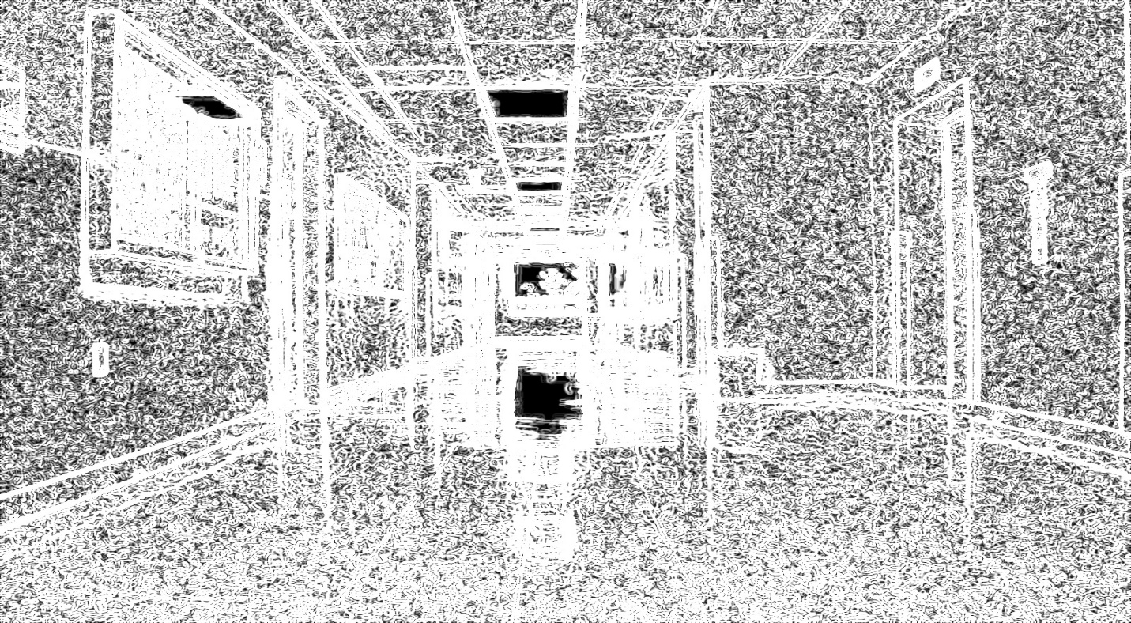

Magnitude4050.jpg

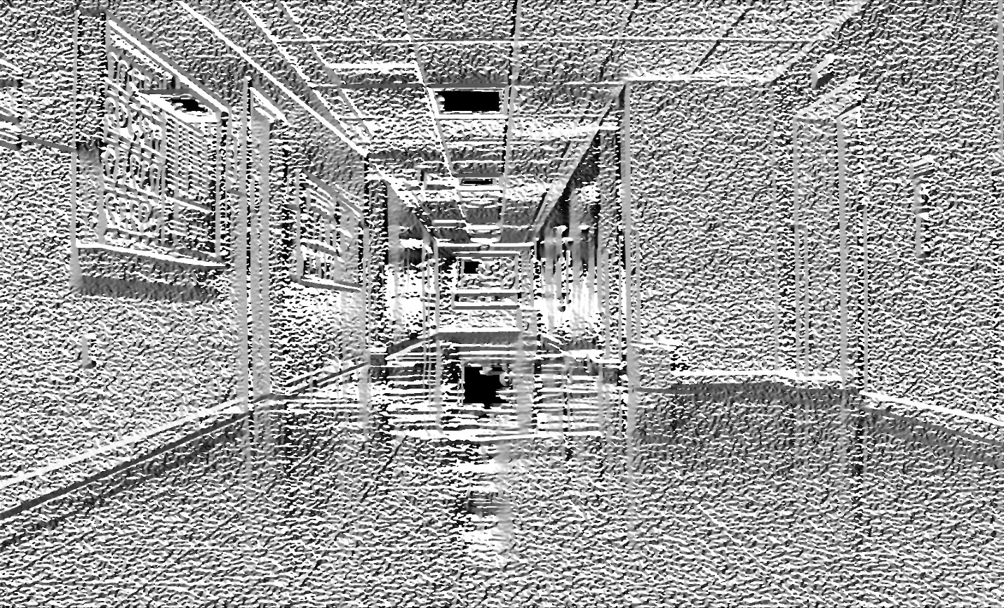

Phase4050.jpg

Also, we divide and round the phase to make it to fall in 36-bin range.

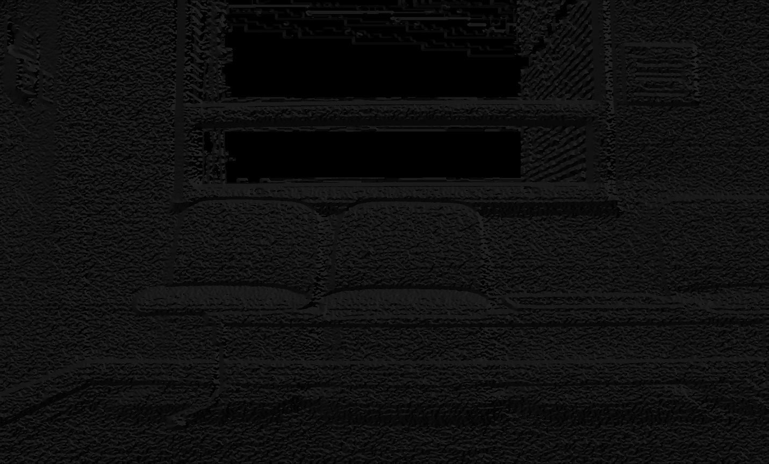

Angle4001.jpg

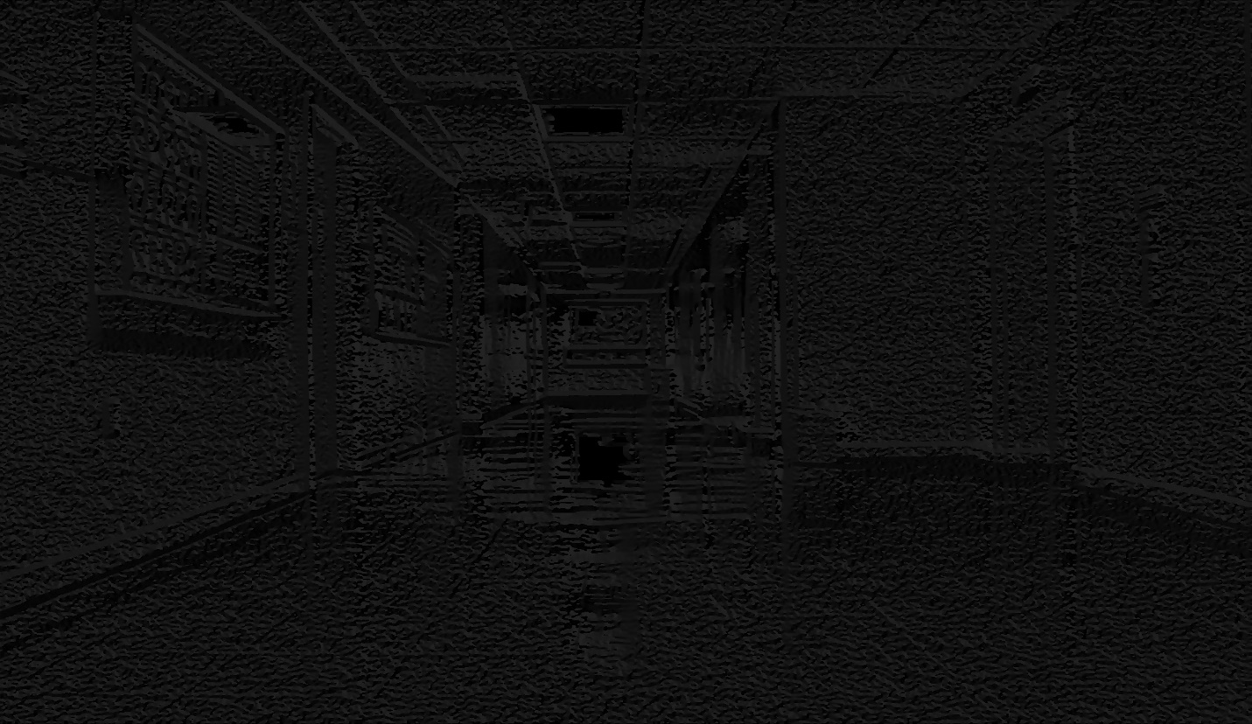

Angle4050.jpg

Later we use the canny edge detection image as a mask and plot histograms for the angles in the images. This masking helps to eliminate all the unwanted edges into consideration.

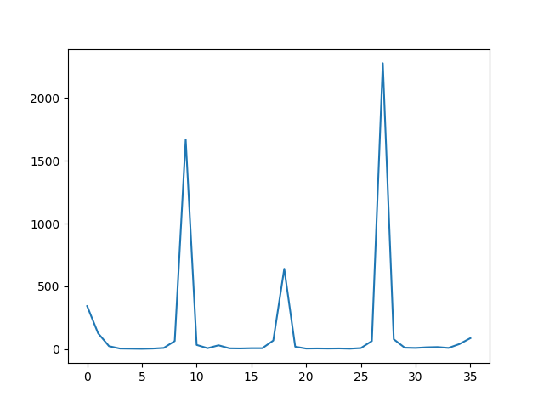

ColorHist4001.jpg

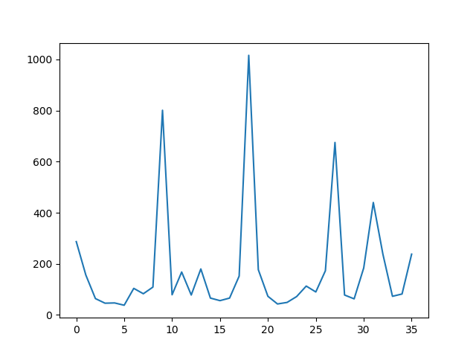

ColorHist4050.jpg

I have then used the histogram intersection and chi-square comparison to compare all the gray and color edge histograms. Unlike the previous homework I have normalized the Chi-Square function.

The results are given below and the histogram comparisons for the images look quite similar.

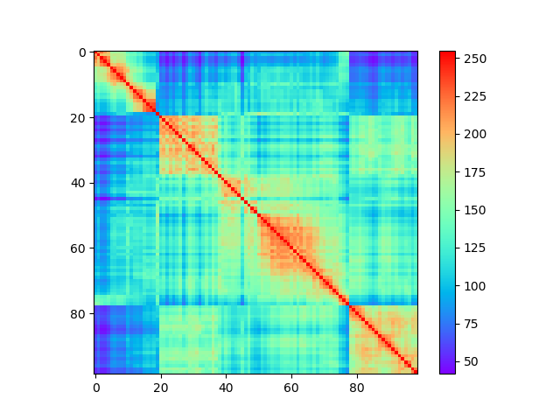

Gray Intersection

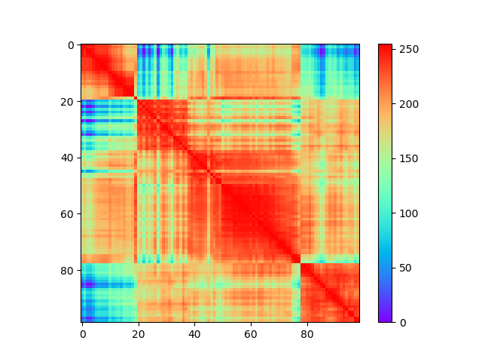

Gray Chi Square

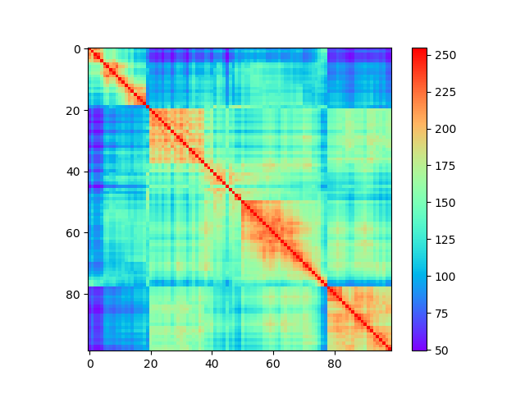

Color Intersection

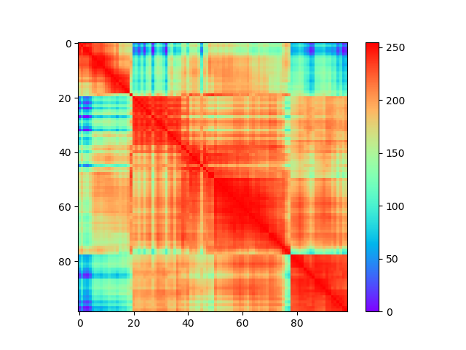

Color Chi Square